
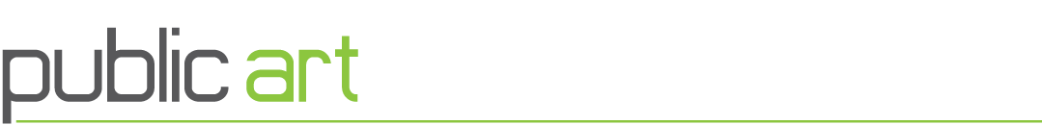
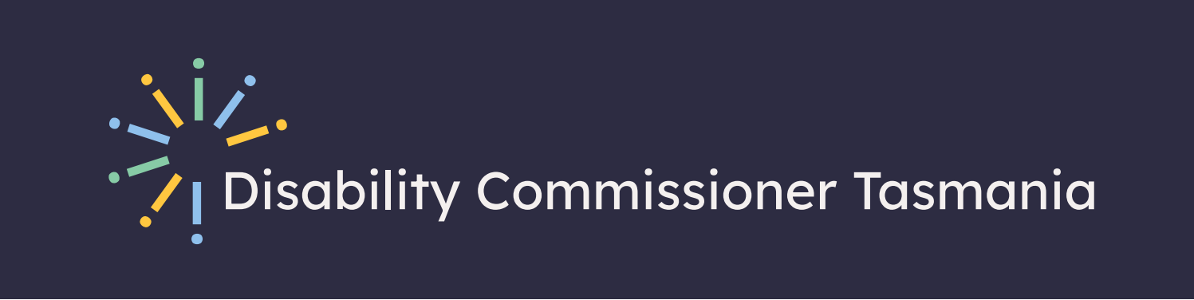

Artist’s Brief
  - Disability Commissioner Tasmania

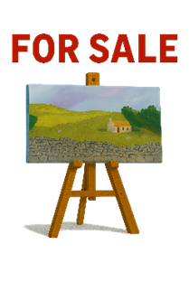
About the project

This project is about buying 2d artwork.
2d means a flat surface.
The artwork will be put inside.

Who can apply?
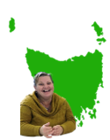
You can apply if you are:
- An artist living with a disability

- Living in Tasmania
Artists of any age can apply.

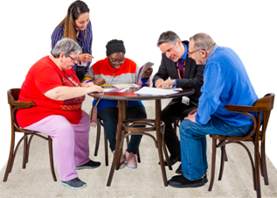
How do we choose
A selection committee will look at the applications and decide.

Who is the client

The Disability Commissioner Tasmania

Who will see the art
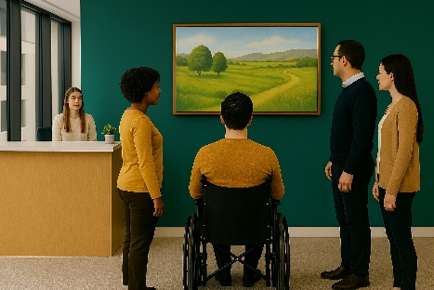
- Staff, visitors and members of the community who visit the Disability Commissioners office.

How much we have to spend
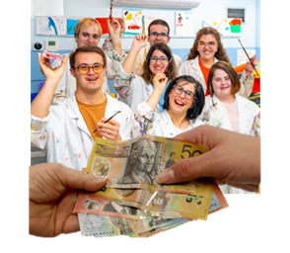
We have $6,480 plus GST.
GST is a tax.

We will buy a number of artworks.

Important dates
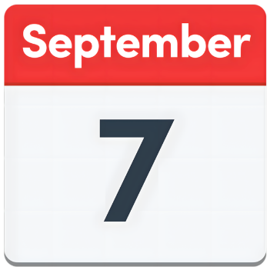
Applications close:
Midnight
Monday 7th September

Contact
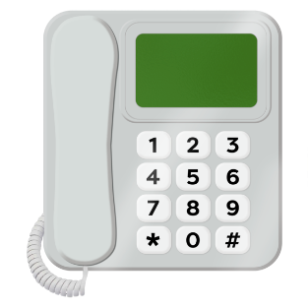
If you need help, contact:
Dr Alicia King
Public Art Officer

Phone: 03 6166 4507

Email: alicia.king@arts.tas.gov.au

How to Apply

Go to this website:
www.arts.tas.gov.au/public_art

Artist’s Brief
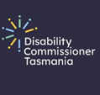
The Disability Commissioner Tasmania helps protect and promote the rights of people with disability in Tasmania.

They work to:


- Prevent harm.
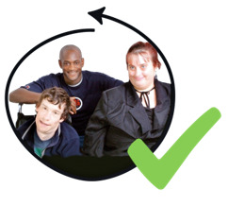

- Promote inclusion.

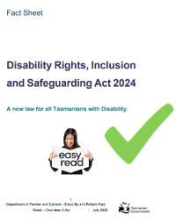
- Make sure that people with disability are treated equally.

They do this by:
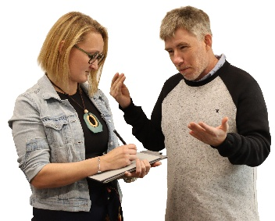

- Listening.


- Looking into issues.

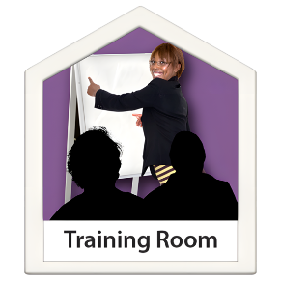
- Education.

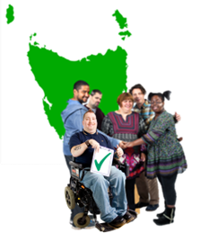
- Working in the community.

Why are we buying artwork
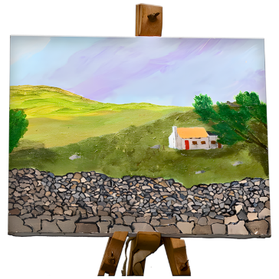
The new office in Hobart is open.
We want to buy two-dimensional artwork to hang on the walls.
two-dimensional means a flat surface.
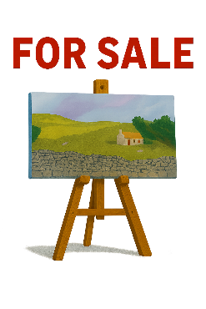
We want to buy art from Tasmanian artists with disability.

The artwork will be enjoyed by:

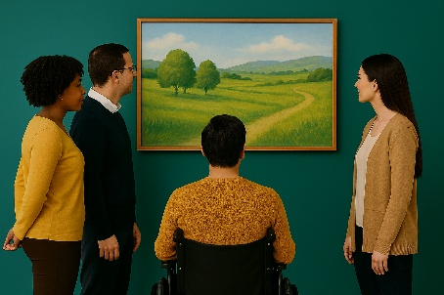
- Staff.

- Visitors.

- Community members.

What type of artwork we want

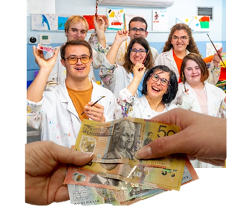
If you have artwork for sale you can apply.
Art can be made by one artist or a group.
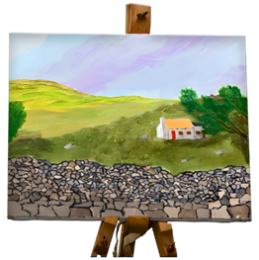
It can be any style, for example:
- Painting or drawing

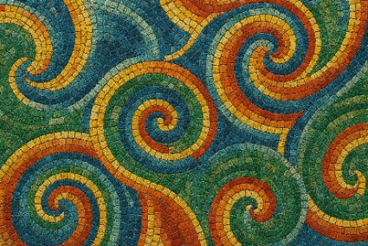
- Printmaking or textiles

- Ceramic pieces or mosaics


- photography or collage

- other long-lasting media (must last at least 15 years)

Artwork theme

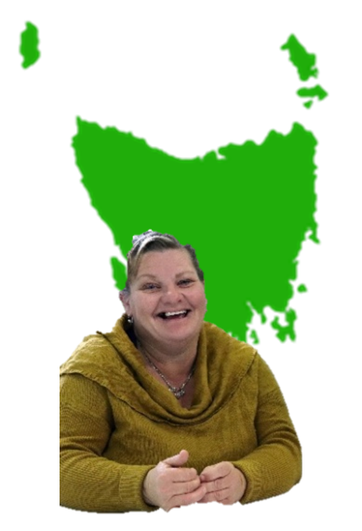
The artwork should be made with a theme in mind.
The theme is:
What living your best life in Tasmania means to you

We are looking for artwork by Tasmanians with disability.

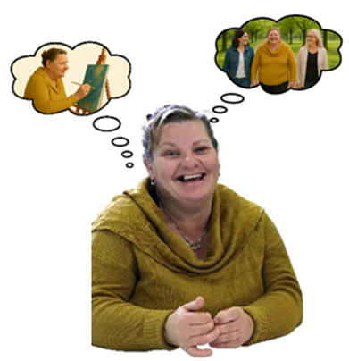
We understand that everyone’s idea of a good life is different.

We want to know what a good life looks like for you.

Artwork Requirements

Artwork must be:
- Suitable for hanging on a wall.

- Finished and ready to hang.

- Last at least 15 years.

- Weigh less than 20kg.

- Priced less than $6,480.00.

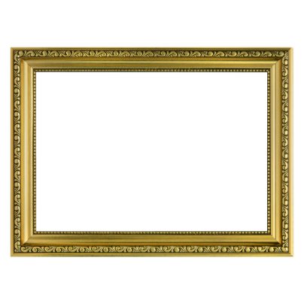
Artwork can:
- Be framed or unframed

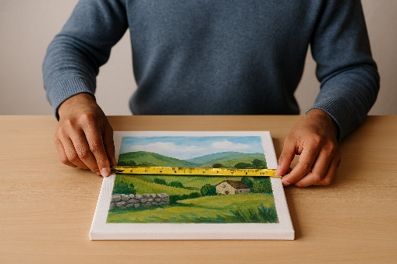
- Be any size up to 3m wide × 1.5m high


How to apply

- Go to www.arts.tas.gov.au/public_art

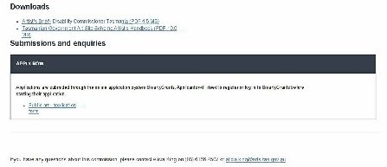
- Find the "Apply Now" section.

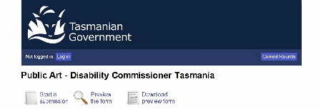
- Click "Public art – application form.


- Fill in the SmartyGrants form and submit it.

If you have not used SmartyGrants before
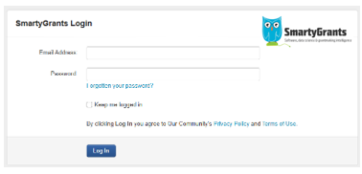
You need to create an account before starting the form.

If you want to look at the form
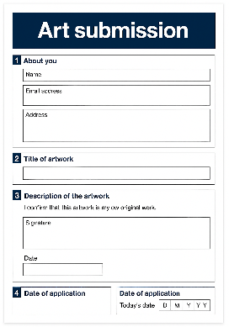
You can look at the form online or download a preview.

If you cannot apply online

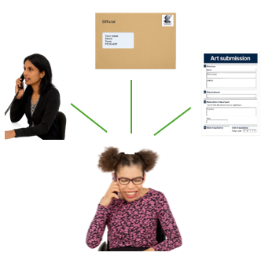
Contact the Program Officer.
they can:
- Send you a form in the mail.

- Complete the form for you over the phone.

- Meet with you in person at Arts Tasmania. you must make an appointment first.

How artworks will be chosen

Selection Committee
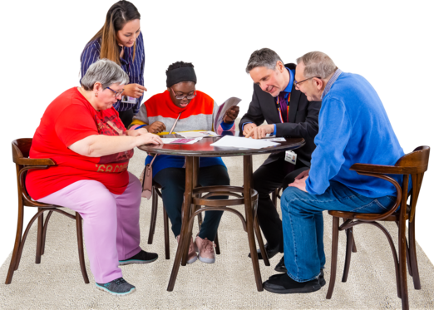
The committee includes staff and partner
agencies:
- Catherine Whitington – Disability Commissioner.

- Trish Mullins – Project Support Officer. Disability Commissioner Tasmania.

- Cat Rogers – Media & Communications Consultant, Disability Commissioner Tasmania.

- Alicia King – Program Officer, Public Art, Arts Tasmania.

- A Consumer Representative.

These members may ask someone else to take their place.

How we will choose the artwork

It will be based on:
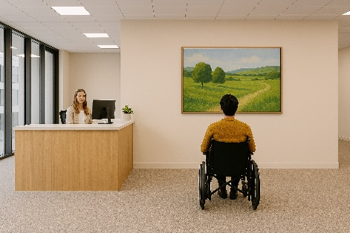
Suitability
Does the artwork fit well with the Disability Commissioner Tasmania
- Space, and

- The theme

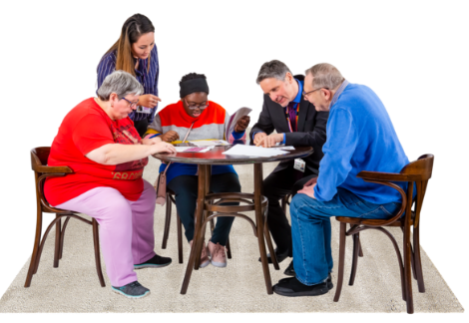
We will look at your:
- Idea for the artwork
- Design
- Materials you use

Benefit
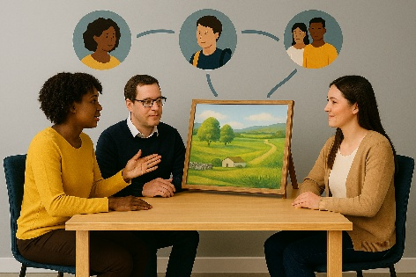
How will the artwork help:
- You as an artist
- People who use the office
- The Tasmanian community

More information

Tasmanian Government Art Site Scheme
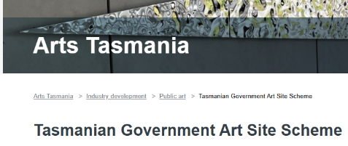

The artwork will be bought through the Tasmanian Government Art Site scheme.
Go to the Arts Tasmania website for more information.
www.arts.tas.gov.au/public_art

Aboriginal and Torres Strait Islander content

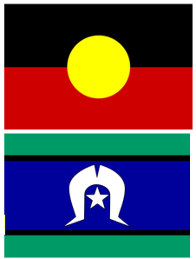
If the artwork includes Aboriginal or Torres Strait Islander content, you must show that you work respectfully with the Aboriginal community.
There is more information about this here:
www.creative.gov.au/investment-and-development/protocols-and-resources/protocols-for-using-first-nations-cultural-and-intellectual-property-in-the-arts/

Working with children
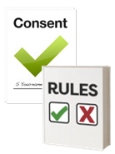
Your artwork might be made by or with children.

A parent or guardian must give consent in the SmartyGrants form.


You should also follow Creative Australia’s Children in Art Protocols.
Protocols are like the rules.
https://keepingchildrensafe.tas.gov.au/


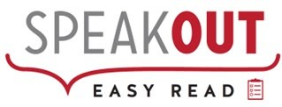

Speak Out Tasmania created this Easy Read document using Photosymbols and custom images. The images may not be reused without permission. For enquiries about the images or Easy Read, please email: easyread@speakoutadvocacy.org

