Visual story: Event Guide
From Barriers to Belonging – an Equity in the Arts Forum

This guide is to help you plan your visit to the From Barriers to Belonging Forum at The Hedberg.

The Hedberg is a performing arts precinct in Hobart, Tasmania.
It is run by the University of Tasmania (UTAS) and the Theatre Royal.
- Address: 19-27 Campbell Street, Hobart TAS 7000
- Main entrance and drop-off: 19 Collins Street, Hobart
If you have any questions about the venue or accessibility, please contact us.
Email: galleries@utas.edu.au

What is a Visual Story?

- A Visual Story is used to prepare a person for a new environment or situation.

- A Visual Story can help increase the predictability of what to expect.

- This can bring familiarity to a process and help reduce anxiety and stress.

- This visual story is written in plain English and uses pictures to make it accessible for everyone.

This Visual Story was made in partnership with Access Consultant, Morwenna Collett.

You can find more information about her work here: www.morwennacollett.com

What is the ‘From Barriers to Belonging’ Forum?

From Barriers to Belonging Forum is a gathering of Tasmanian arts organisations, people with disability (including artists) and anyone interested in the arts.

The forum will include:

- Presentations and panels

- Interactive discussions and workshops

- Performances by artists with disability

- Networking sessions

- Information sharing

Together, we’ll look at how to remove barriers, support artists with disability, and build a plan for Tasmania so everyone can participate.

You can find out more about the Forum online: www.arts.tas.gov.au/inclusive-arts/from-barriers-to-belonging

From Barriers to Belonging Forum will take place at The Hedberg on:
- Thursday 5 February 2026
- 9.15am – 5.00pm, with optional networking drinks afterwards

You can arrive at any time and stay as long as you like.

If you arrive in the middle of a presentation or panel, an usher will guide you to enter quietly.

There is also an online attendance option if you are unable to attend in person.

The Forum is free but you will need to register for a ticket before you arrive for catering and accessibility purposes.

The event is currently booked out, but you can join the waitlist on the Theatre Royal website: www.theatreroyal.com.au/shows/barriers-belonging-forum

If you can no longer attend, please contact us on galleries@utas.edu.au so we can provide your ticket to someone else.

How to get to The Hedberg
The Hedberg is a venue for music, theatre and events.
Some of the spaces in The Hedberg include:
- Ian Potter Recital Hall
- The Salon
- The Vanessa Goodwin City Room
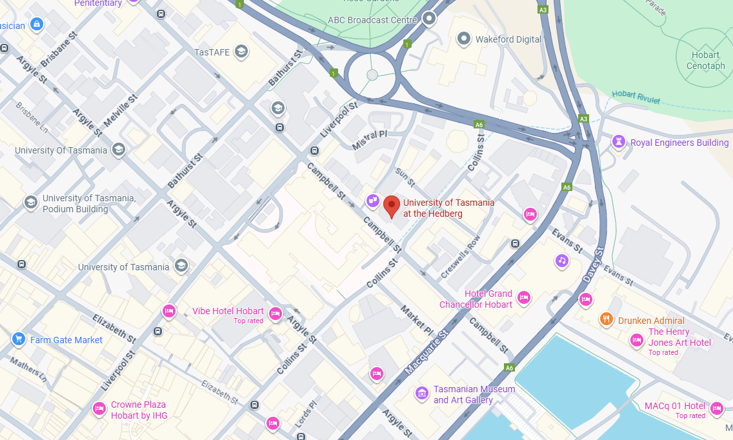

You can find out more about visiting The Hedberg on the website’s ‘Plan your Visit’ page and the ‘Accessibility’ page.

There is a virtual tour of the venue available too.

Arriving at The Hedberg

This is the front of The Hedberg building on Collins Street.  You can arrive by car, taxi or bus.  The closest bus stop is approximately 200m away on Campbell Street. | 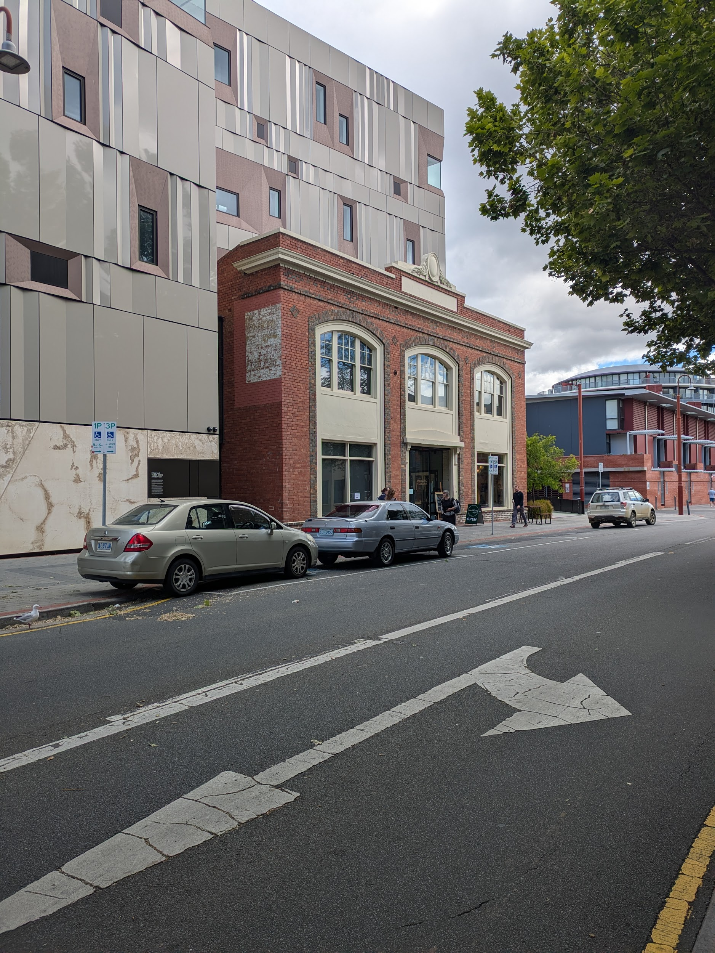
The entry of The Hedberg has an automatic glass door. | 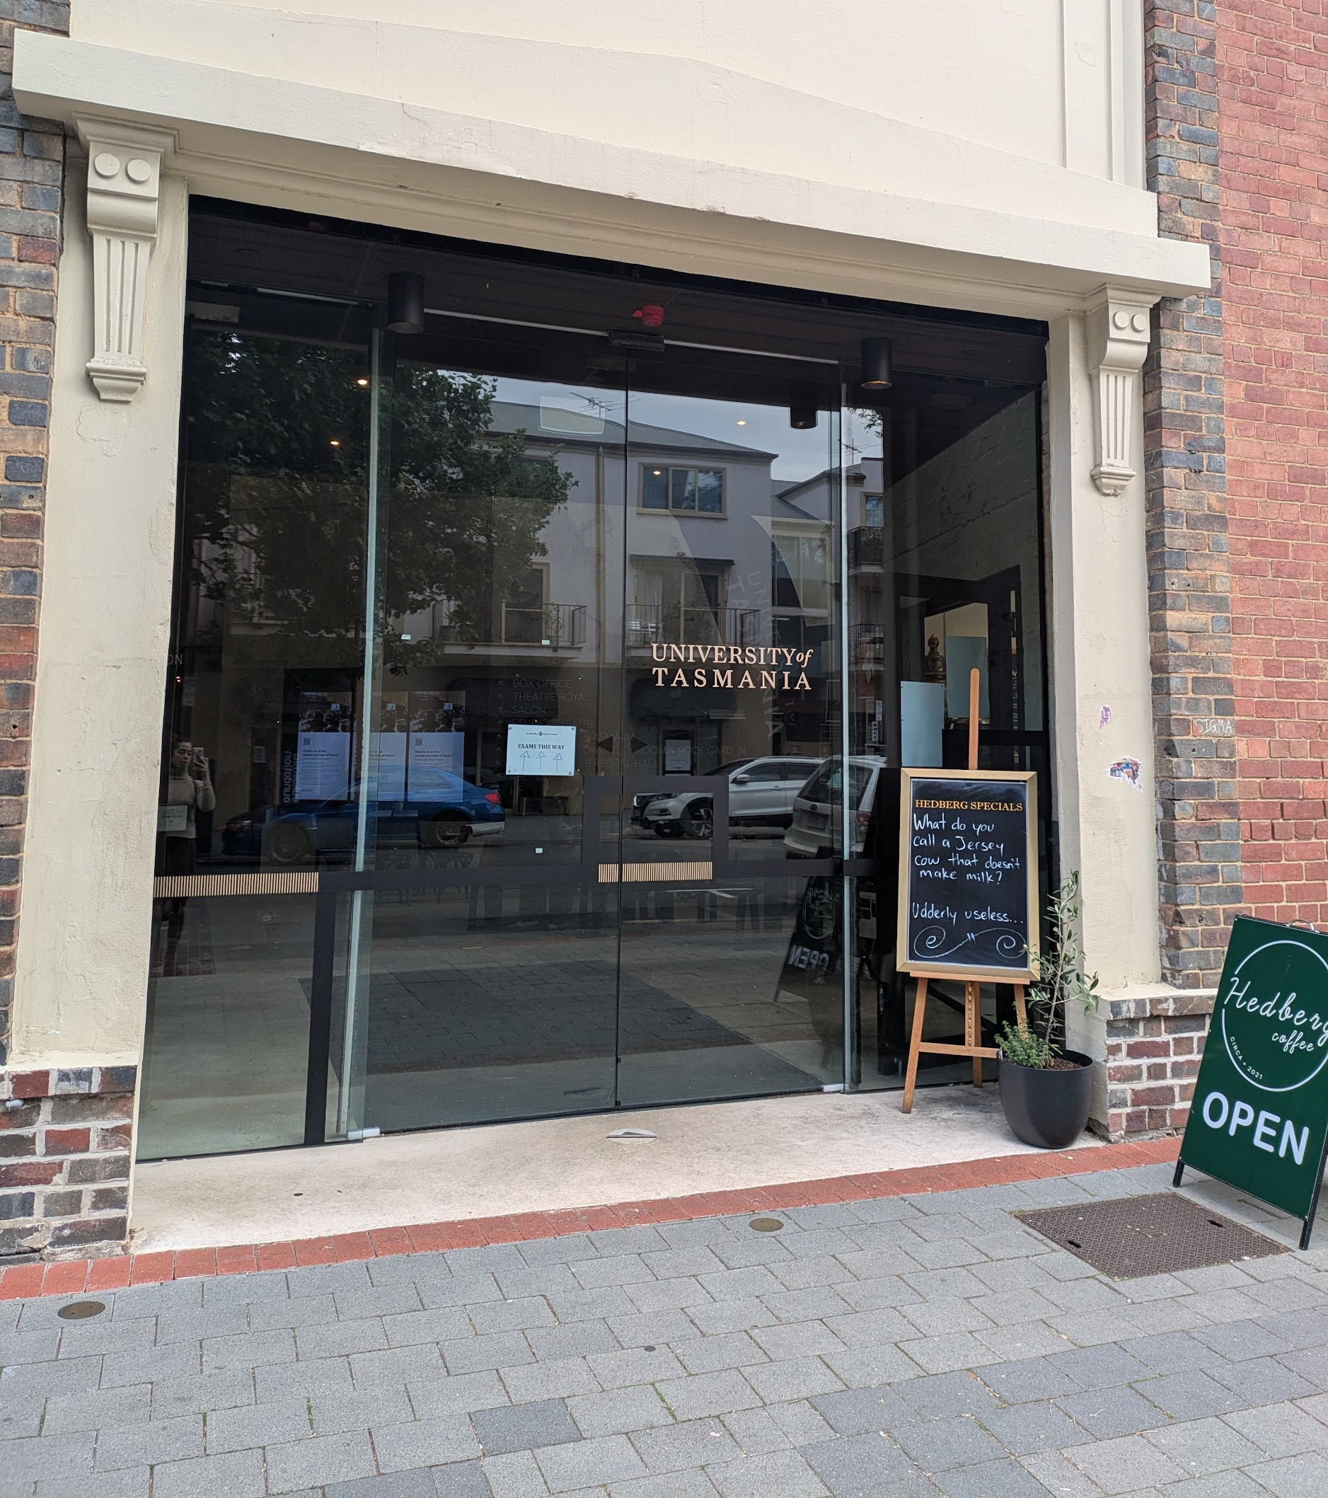

There are drop-off and pick-up areas on Collins Street outside the entrance to The Hedberg.

There are also 2 designated accessible parking spaces on Collins Street.

There is additional short-term accessible parking spaces just past The Hedberg, before the Brooker Highway (indicated by the red lines on this map) | 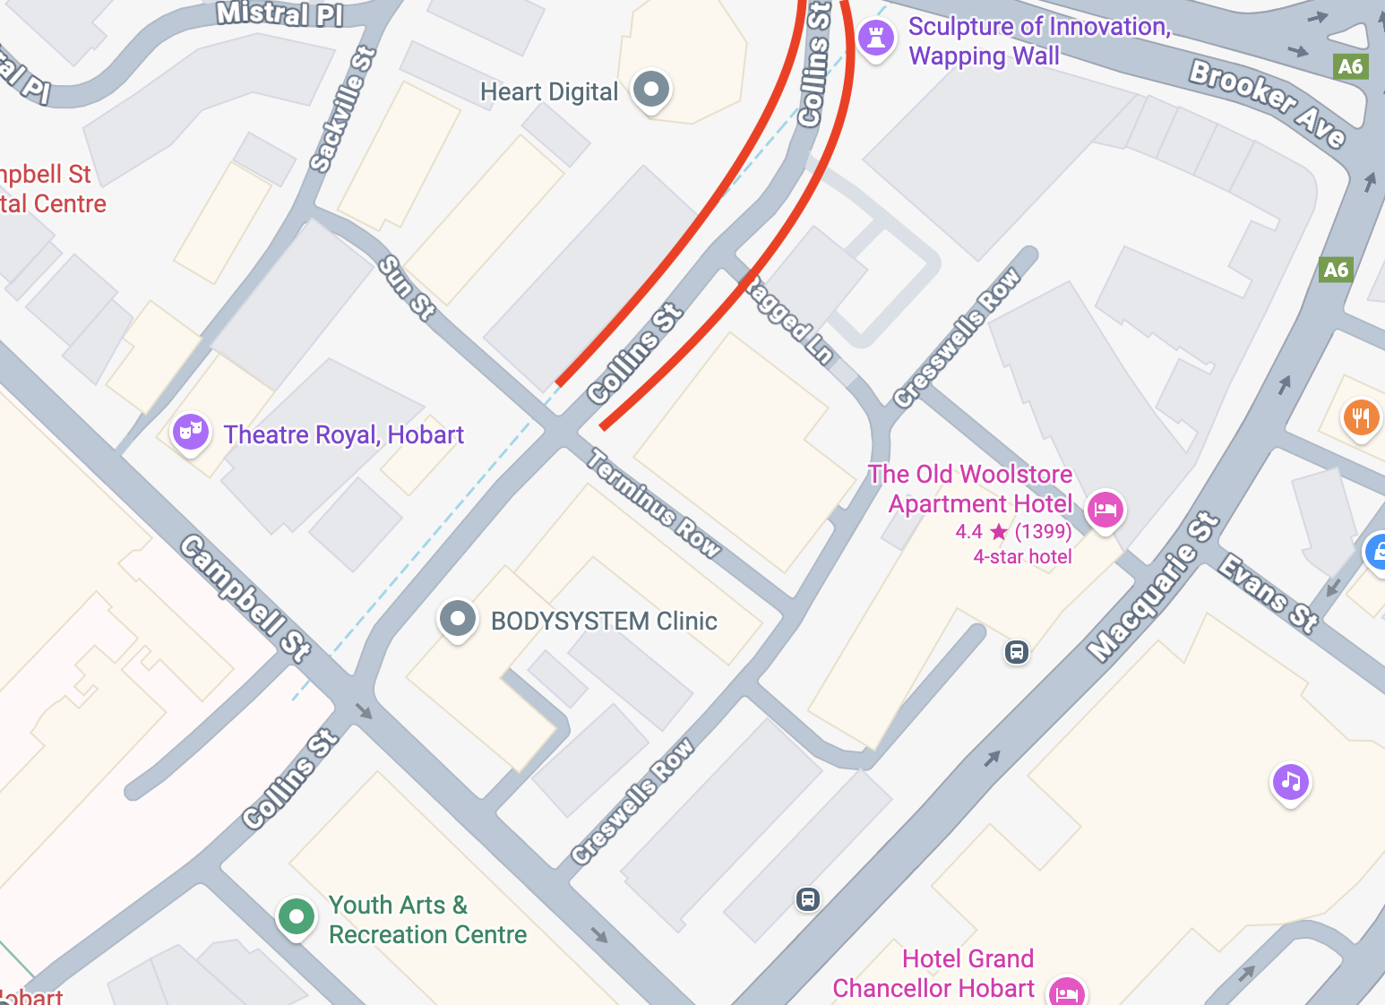

If you need long-term parking, there is more information here: https://www.theatreroyal.com.au/where-park

Inside The Hedberg
After entering the building from Collins Street, you will be in the entrance area. It might be busy.

You will see people from the From Barriers to Belonging Forum team checking registrations and handing out name tags.

The Forum will take place in 4 main spaces:  - Ian Potter Recital Hall  - The Salon  - Level 2 foyer (catering)  - Level 4 foyer (post-event drinks)  From Barriers to Belonging Forum will mostly be in the  Ian Potter Recital Hall which is straight and to the left from the entrance area. | 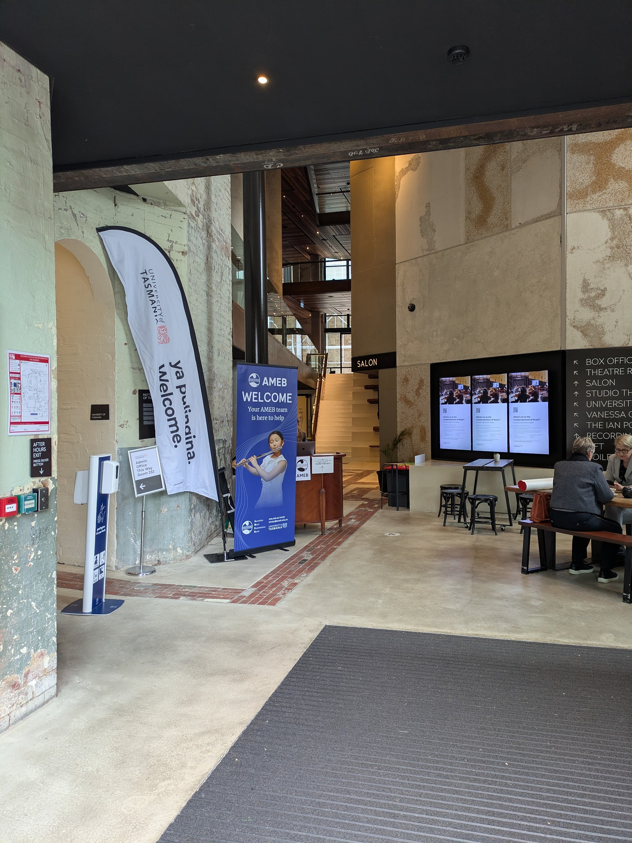

All spaces are wheelchair accessible, have flat entry and lift access.

From the entrance you can also access the Quiet Space, Bathrooms and Bar.

If you need help finding your way you can ask a staff member.

Ian Potter Recital Hall

The Ian Potter Recital Hall is straight ahead and to the left from the entrance area.

For the Forum, the Ian Potter Recital Hall will be used as the main gathering space.  It will be set up so that a panel of speakers can sit on the stage in chairs.  There will be some artworks behind the speakers on the stage. | 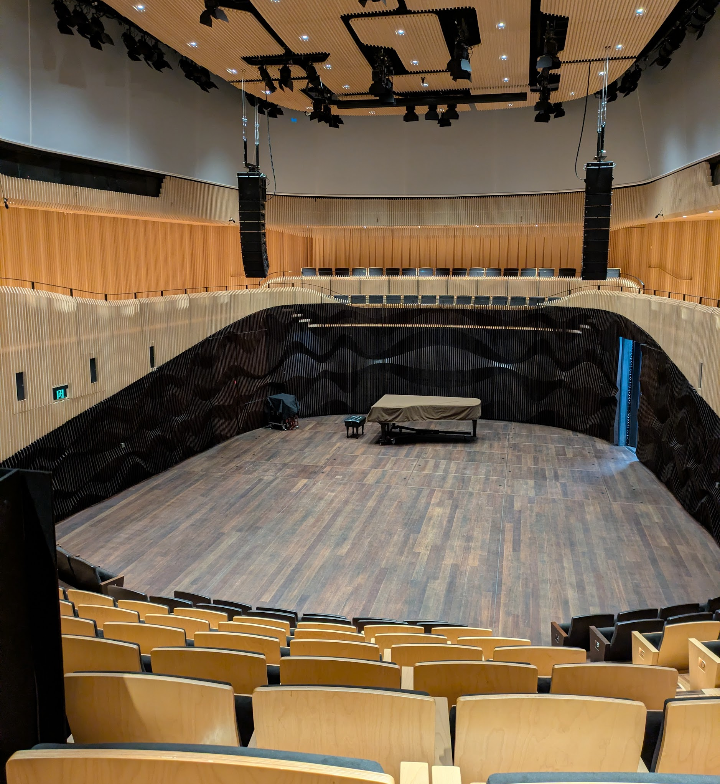
To enter the Ian Potter Recital Hall, an usher will open a double set of automatic doors. This entrance will lead you to the stage level.  A lift is available to the left of the Recital Hall doors. It will take you to an entrance at the top of the seating. | 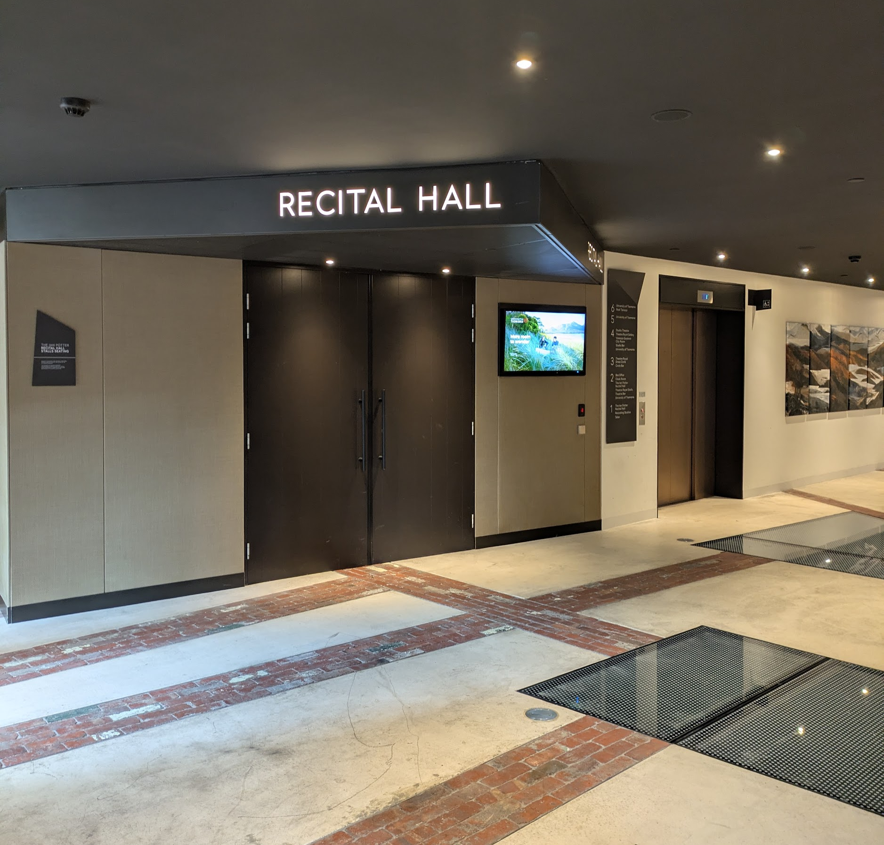
If you enter at the ground level, there are stairs that are curved and have no handrails.  Wheelchair seating is available in the front row on the ground floor as well as the top level.  There will be quiet music playing as you enter the Ian Potter Recital Hall.  The space will be gently lit. | 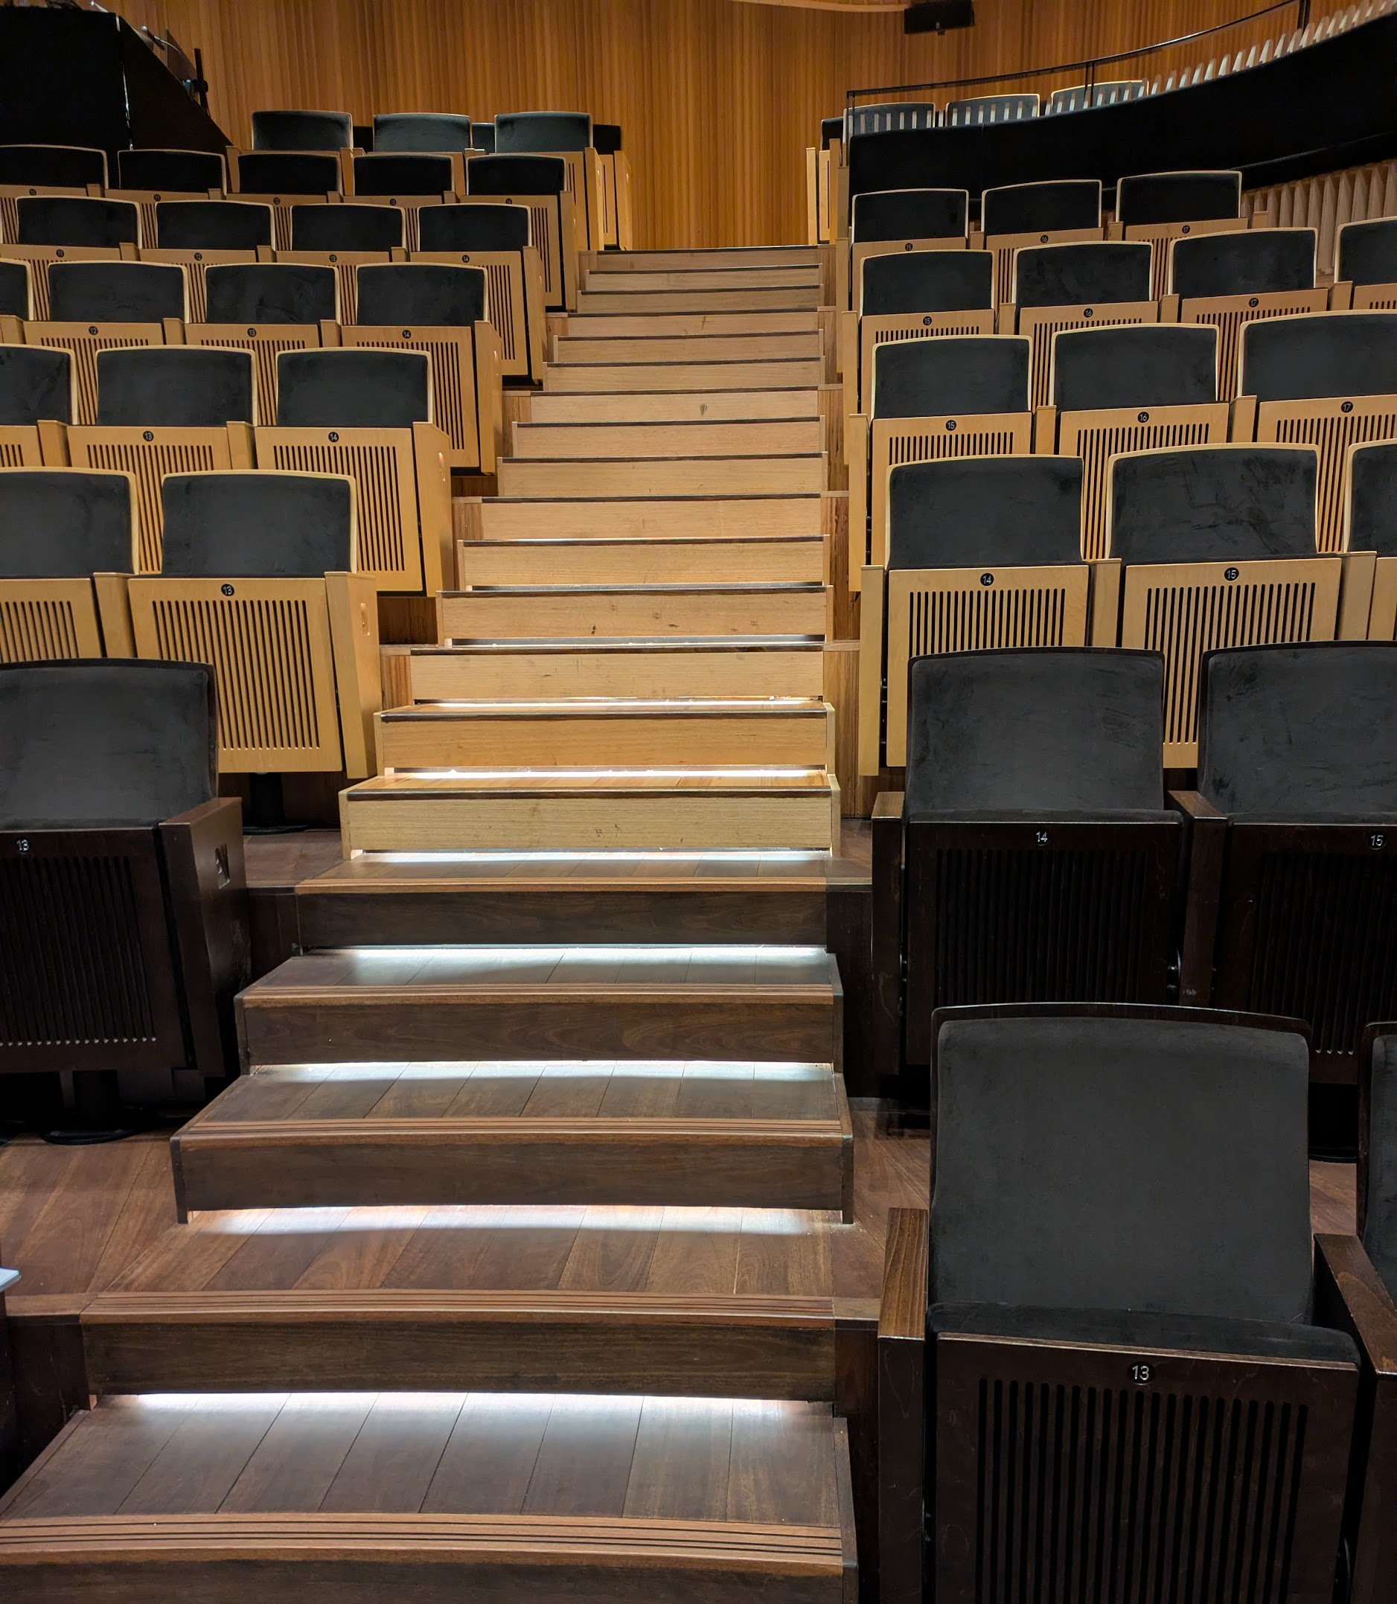
To exit the Ian Potter Recital Hall, a staff member will help you.  Doors on both levels are automatic and inset to the walls. Staff will assist with opening the doors for entry and exit. | 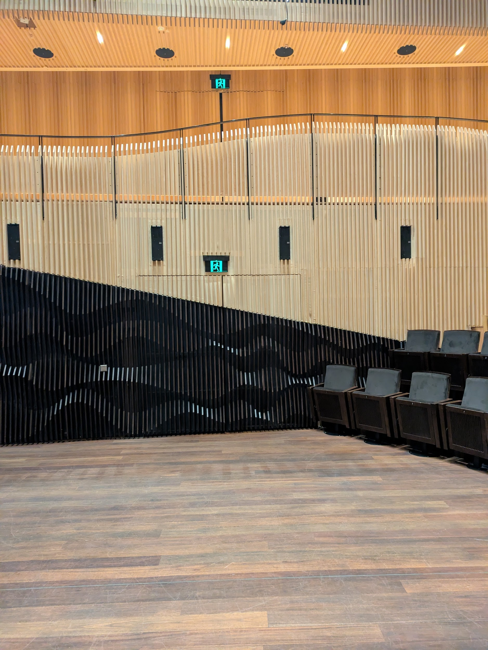

The Salon

The Salon is straight ahead and to the right from the entrance area. It is opposite the Ian Potter Recital Hall.

For the Forum, the Salon will be used in the afternoon for Session 3 as an activity and movement space.  Lighting levels are lower in the Salon.  There will be tables and chairs set up in the room. | 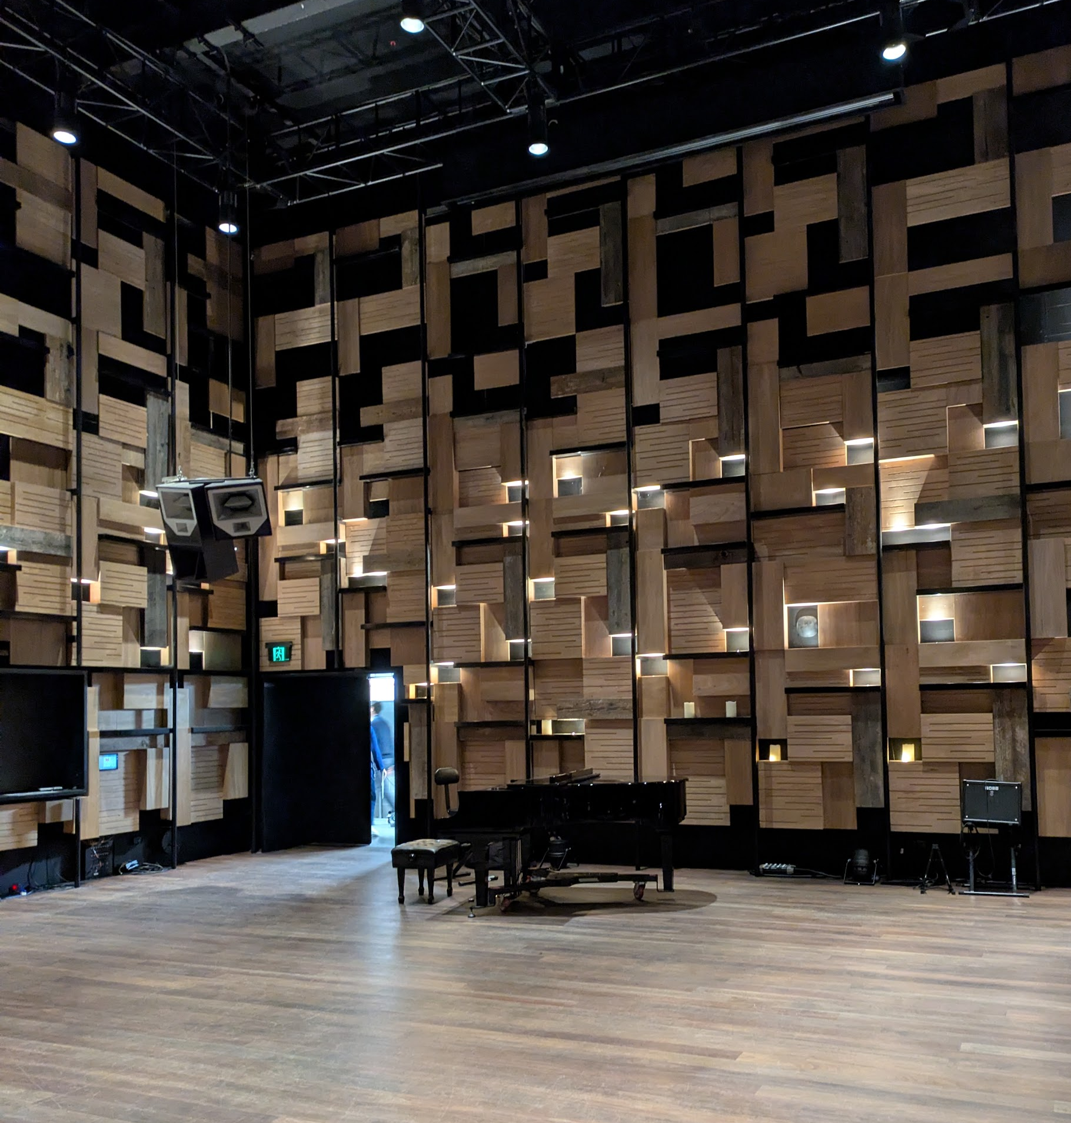
The floor is hardwood and level.  To exit this room, a staff member will help you operate the doors. | 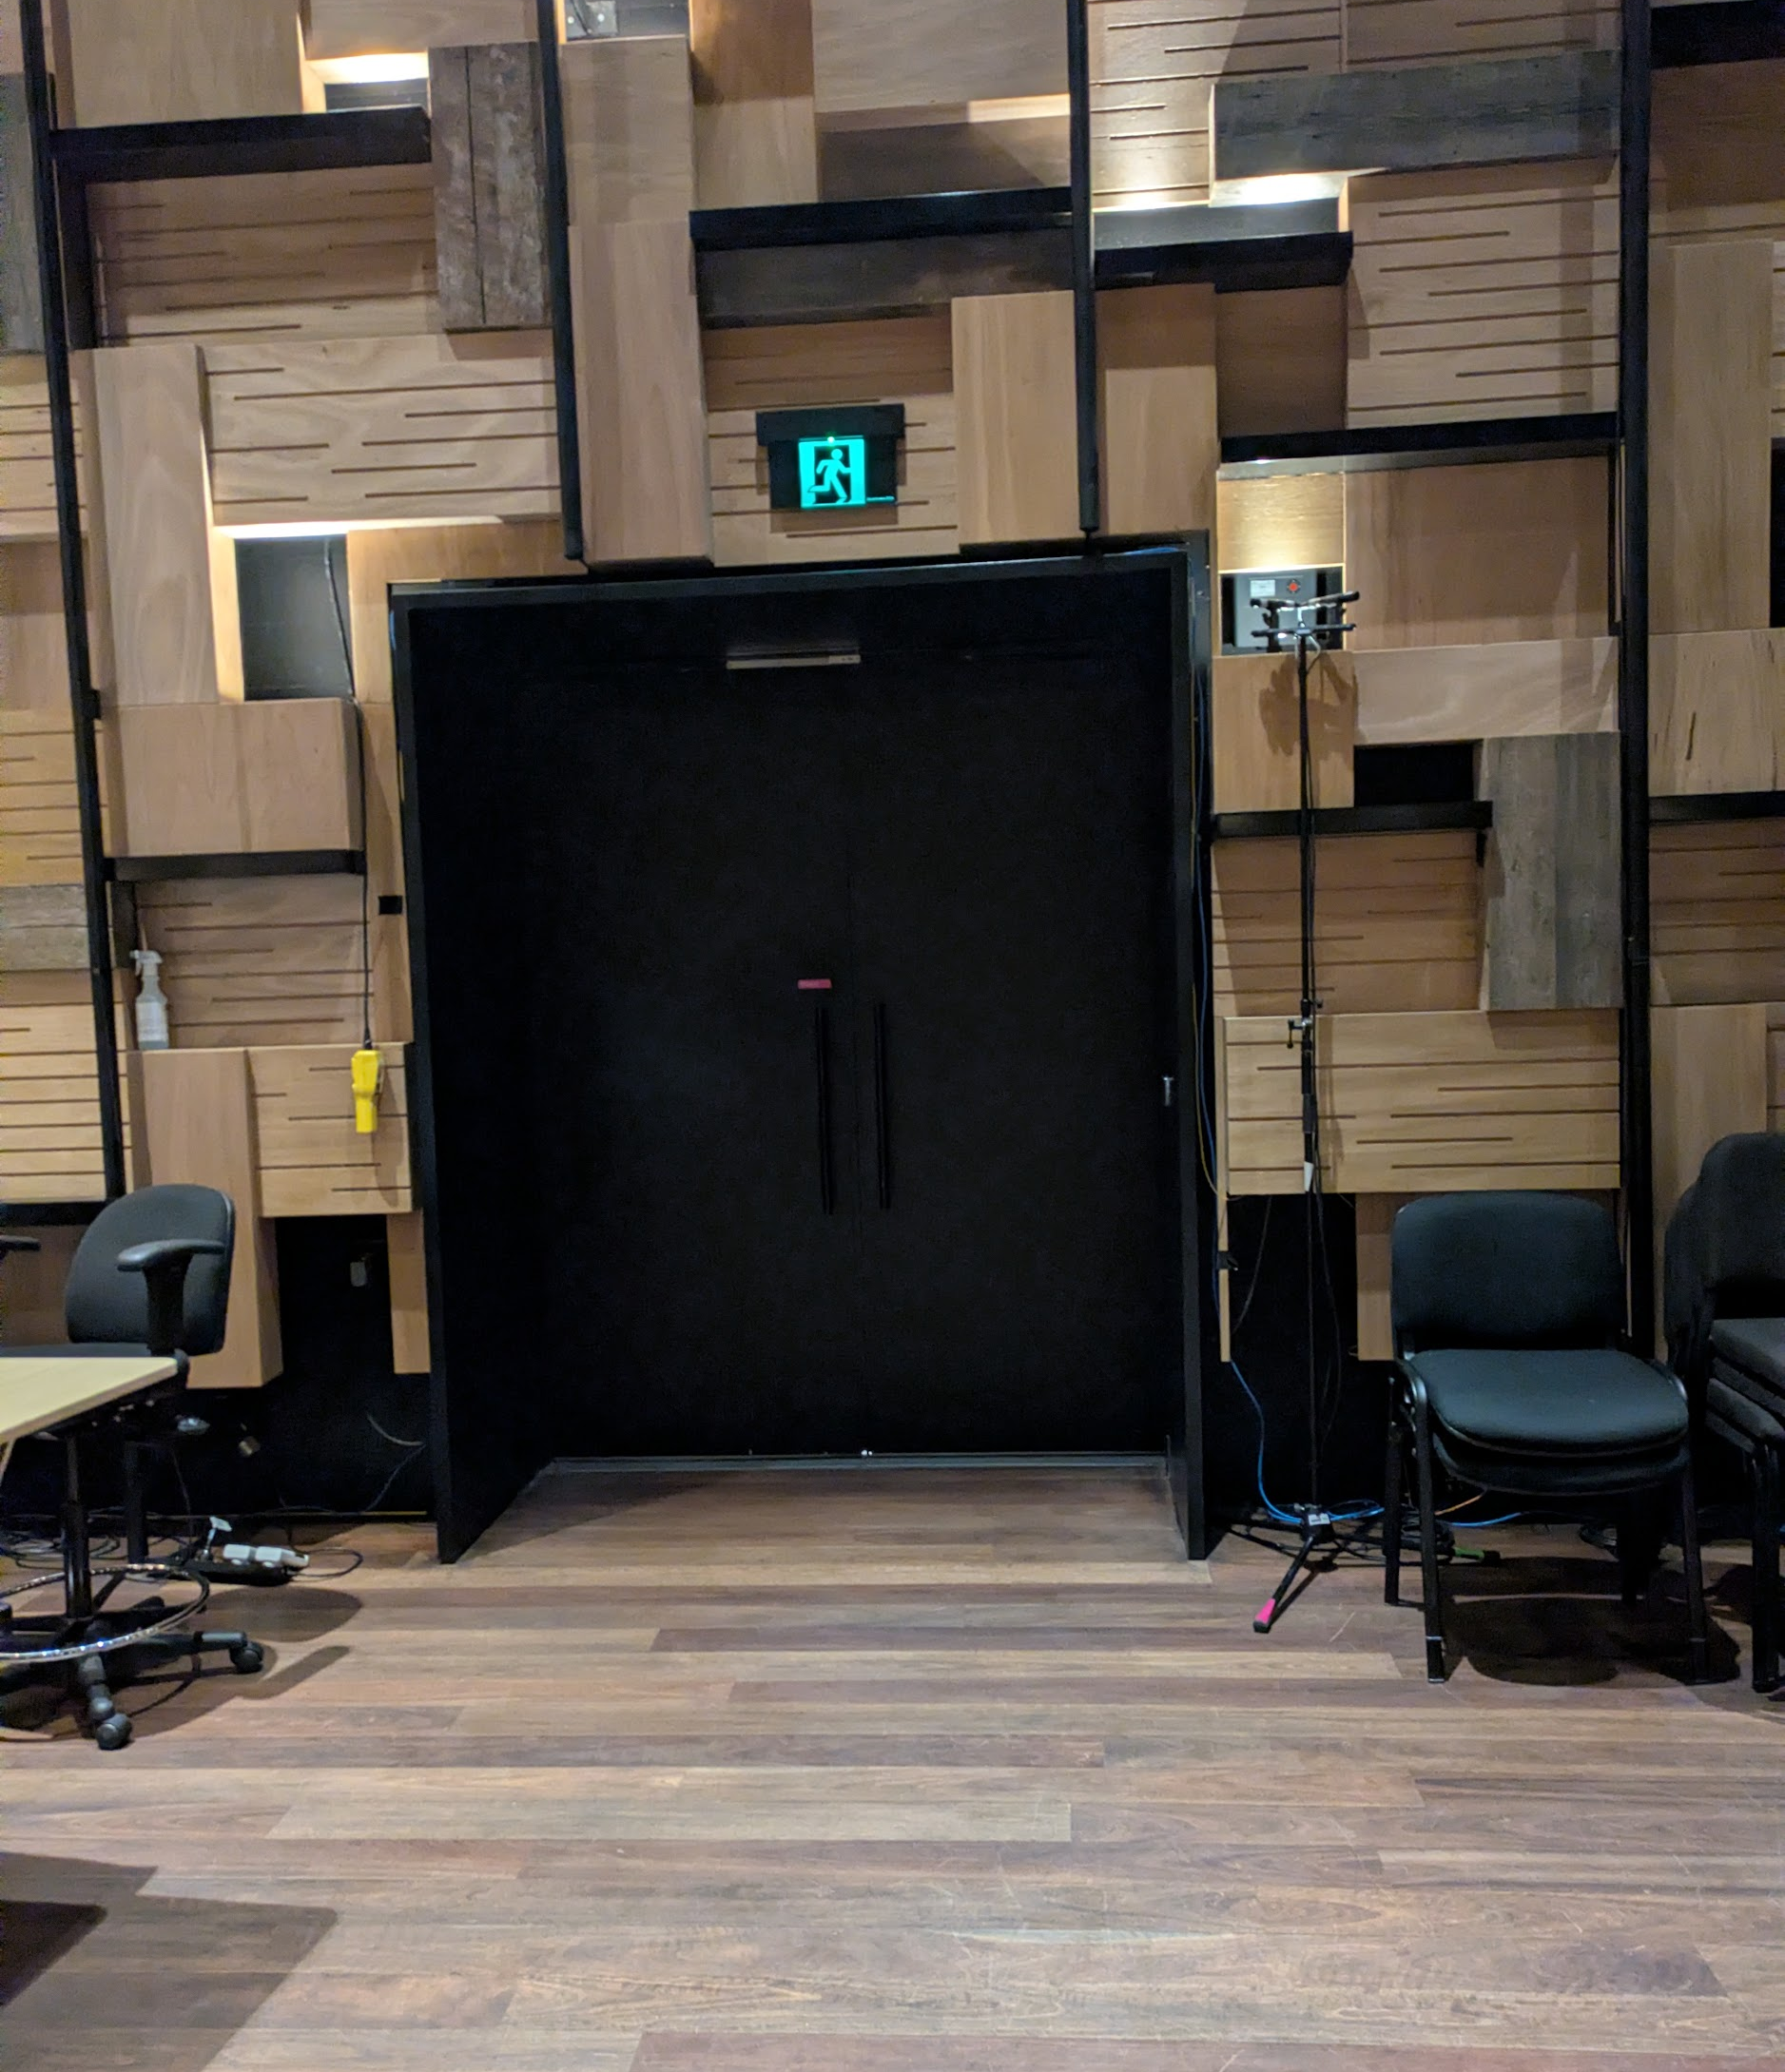

Quiet Space

The Forum Quiet Space is a small room, located inside the entrance area, on the same side as the Ian Potter Recital Hall. It will have a sign on the door.

A Quiet Space is a calm area where you can take a break from noise, crowds, or sensory overload.

You can take a break and use the Quiet Space any time during the day.

It will be set up with bean bags, chairs and cushions, low light and fidgets. It has carpet on the floor and some natural lighting.

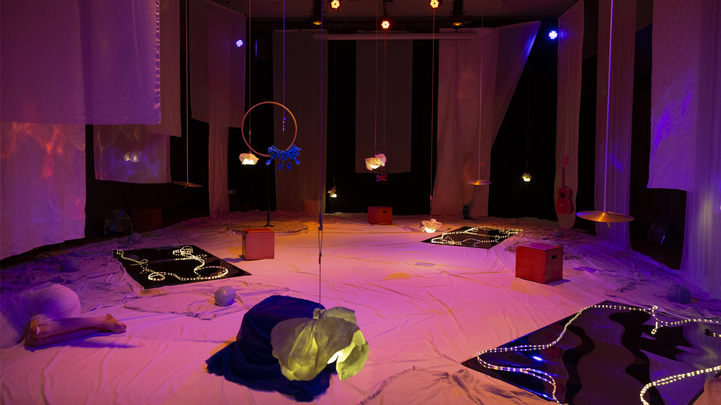

This picture is an example of what a quiet space can look like.
It is from Arts Centre Melbourne (image credit: Pia Johnson).
Bathrooms

The Hedberg has gender neutral and accessible bathrooms on the ground level and on level 2 and level 4.

To access the bathrooms from the entrance area, go past the Ian Potter Recital Hall and the lift.  You will see double glass doors which open to a short corridor.  At the end of the corridor, there are multiple bathrooms available. | 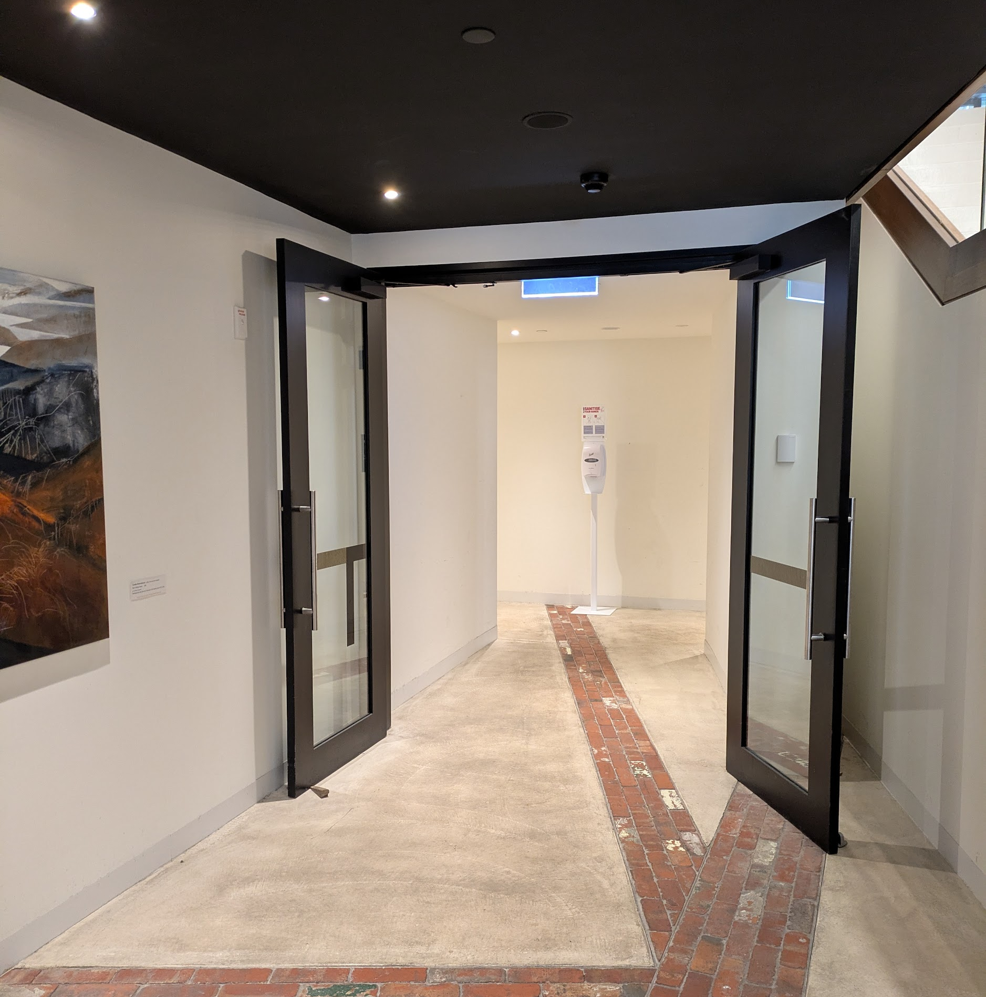
The female bathrooms are on your left.  The male bathrooms are on your right.  Both have an ambulant stall.  There is one gender neutral accessible bathroom on the fair right, which also has baby change facilities. | 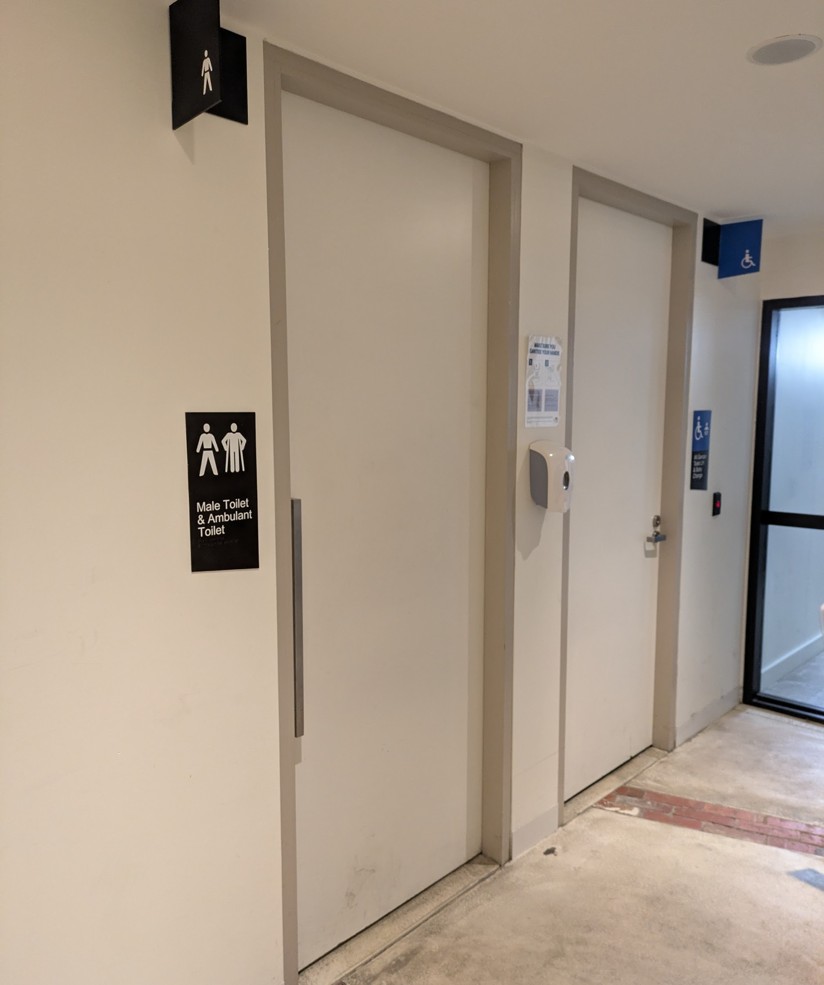
The accessible bathroom door opens inwards.  The toilet has a left hand grab rail, rear grab rail and back rest.  There is also a baby change table, sink (with automated tap) and hygiene facilities inside. | 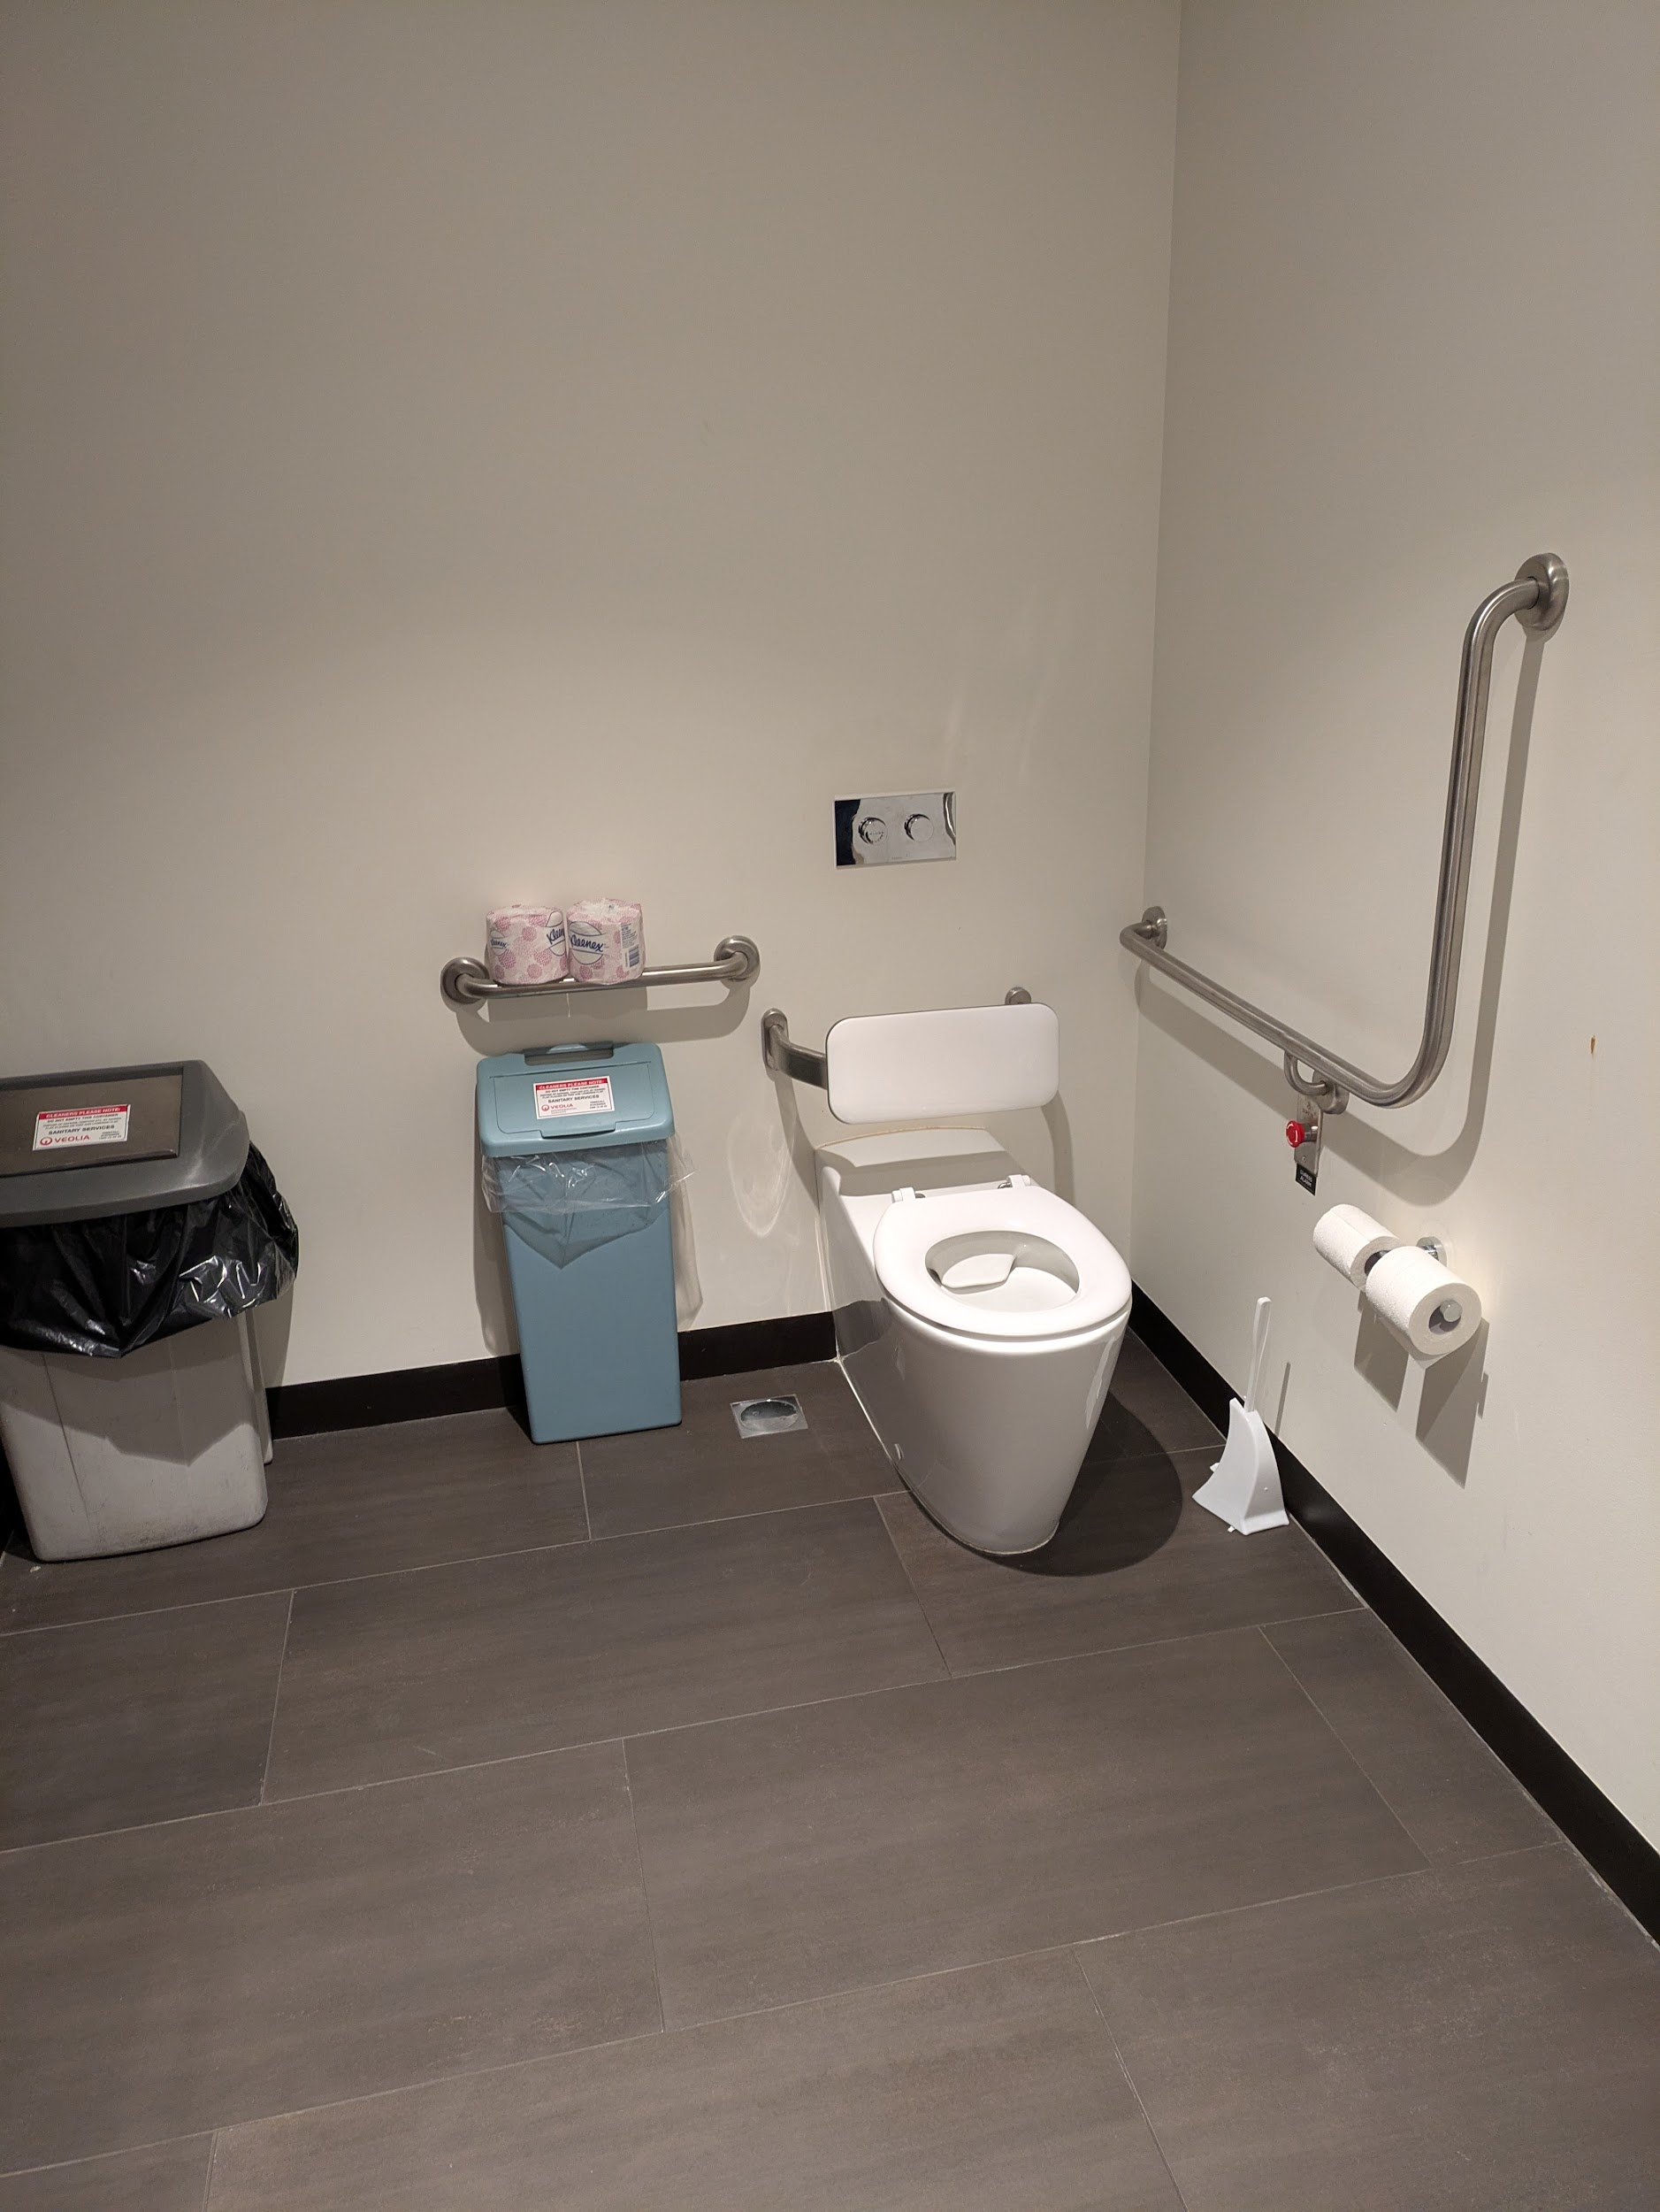

Bar (food and drinks)
For the Forum, we will provide food and drinks for morning tea, lunch and afternoon tea.

You are welcome to bring your own food and drinks if you prefer, though these cannot be consumed inside the Ian Potter Recital Hall or the Salon.

Morning tea, lunch and afternoon tea will be served in the bar on level 2.

Food and drinks include:  Coffee & Tea  Morning tea:  - Granola + yoghurt  - Coconut chia pudding  - Pastries  Lunch:  - A selection of salads  - A selection of sandwiches  Afternoon tea:  - Cheese and crackers  - Banana bread  - Fruit platters  Water will also be available. | 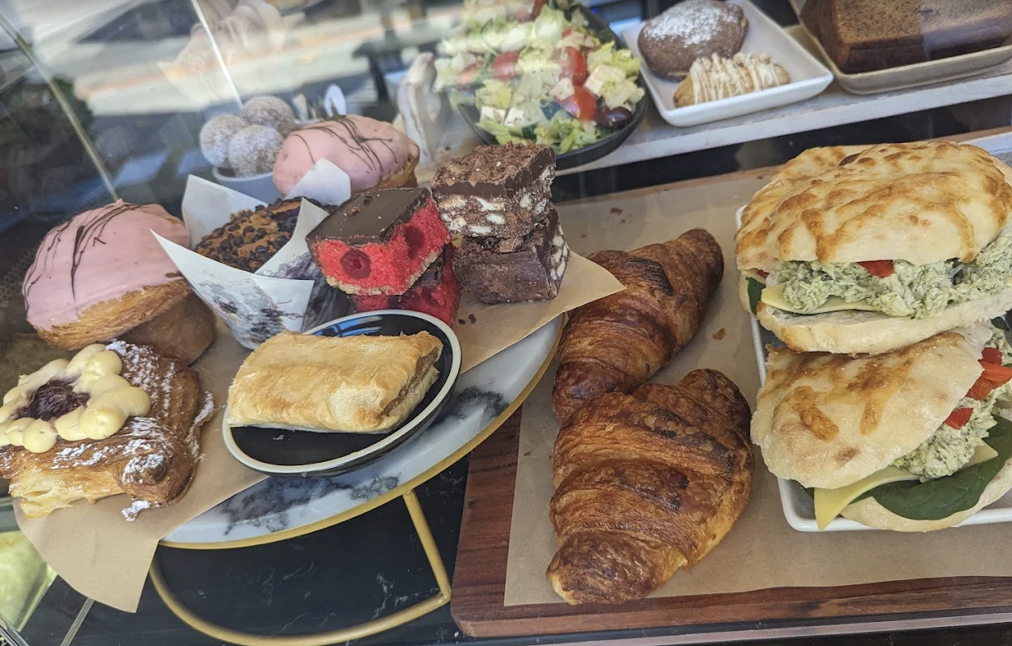

You can sit and eat on level 2.  There is a variety of seating available, including cushioned chairs with back support. | 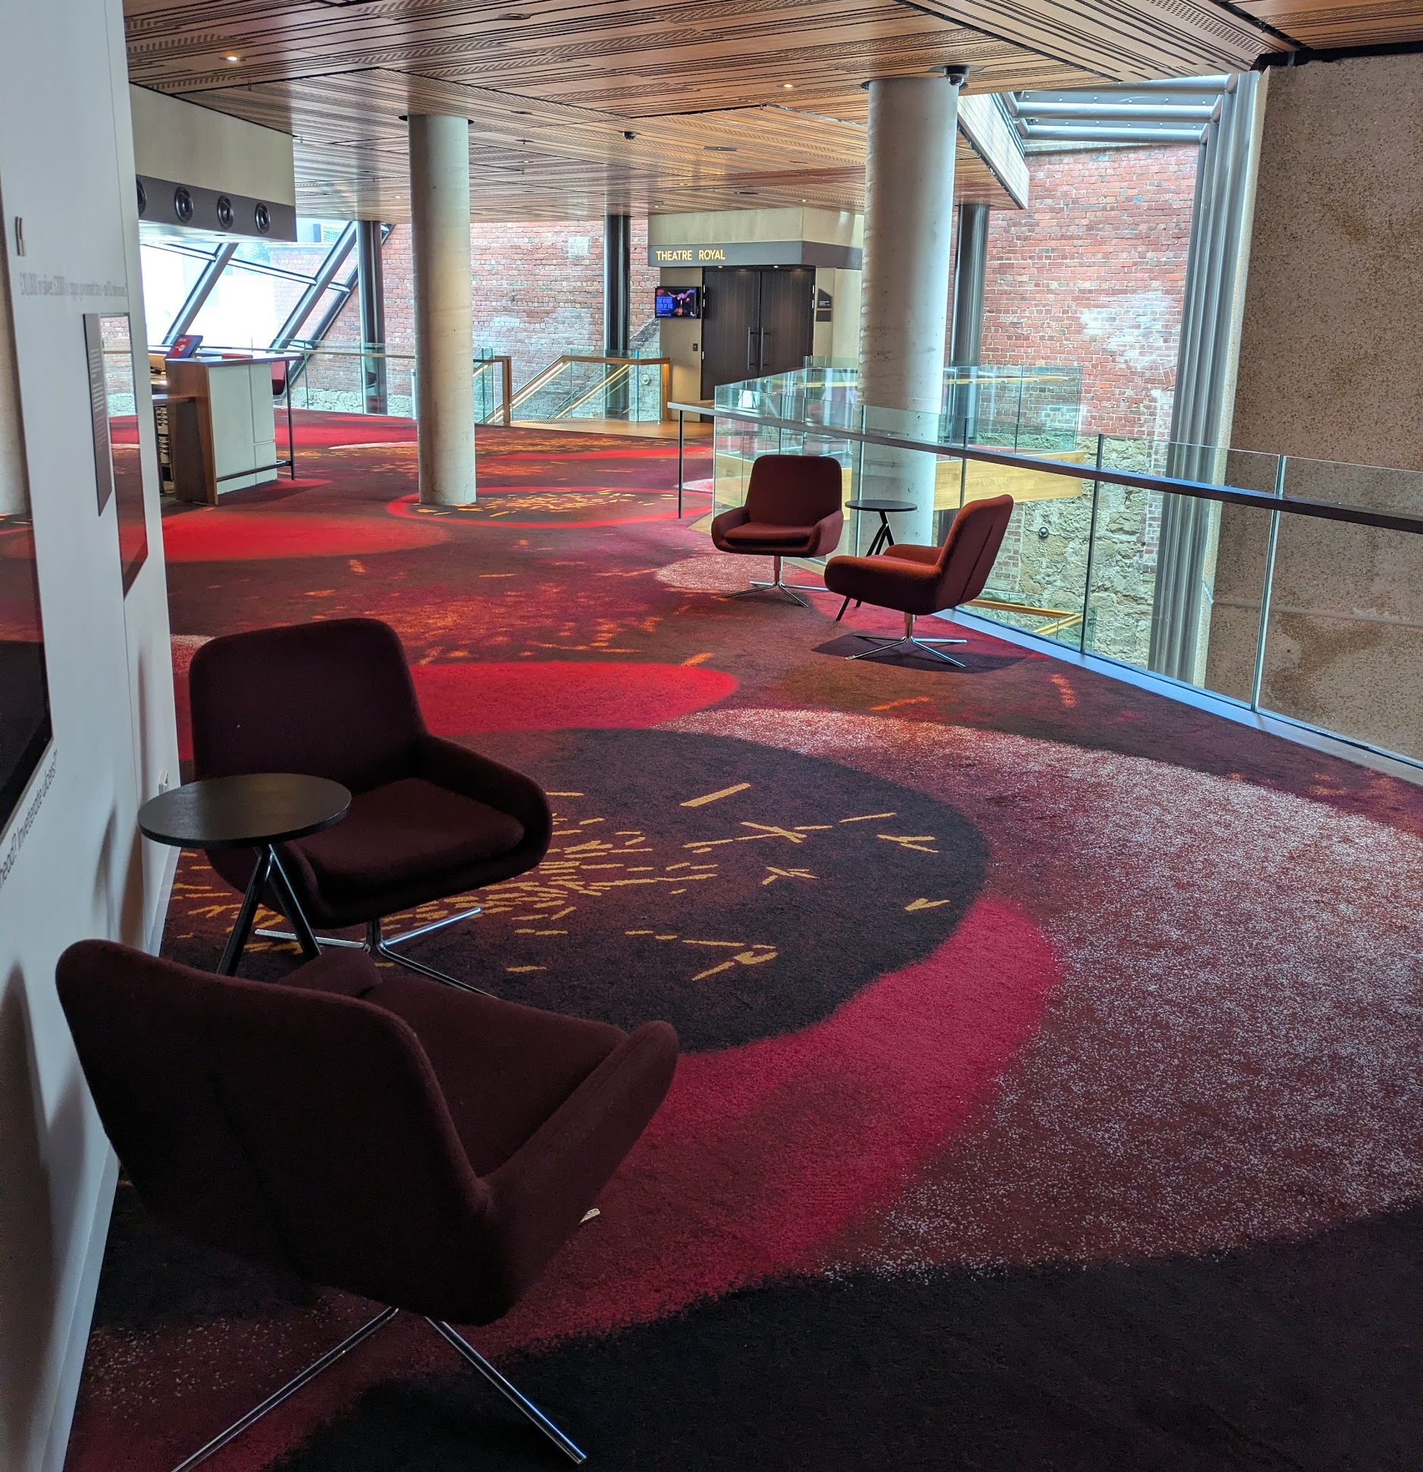
If you prefer, you can leave The Hedberg for local food and drink options or a break. | 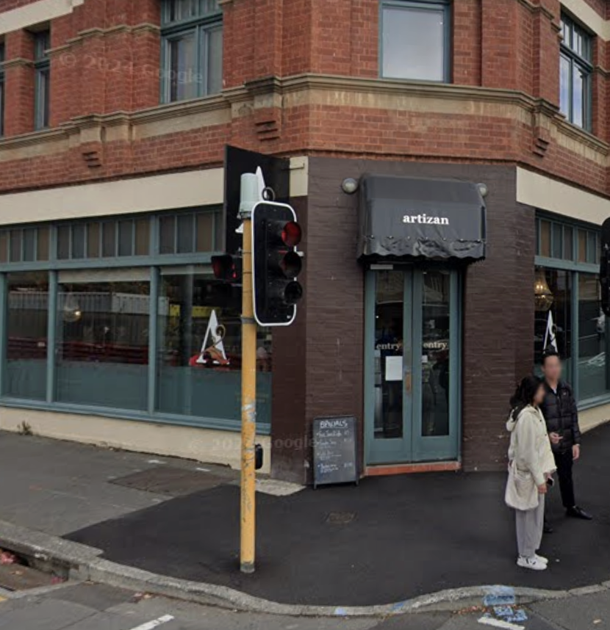
Morning tea and afternoon tea will be 30 minutes each.  Lunch will be 60 minutes. | 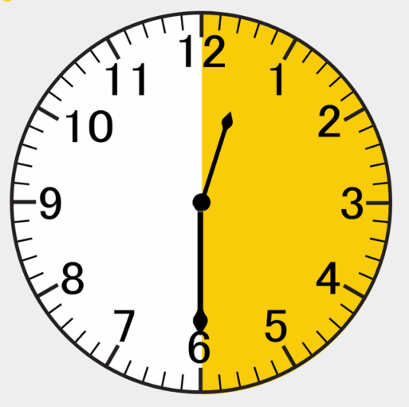

What to expect at the Forum

Everyone is welcome at this event.

When you arrive, you will be greeted by someone from the From Barriers to Belonging team.

They can help you if you have any questions.

- The Forum starts at 9.15am but you can arrive at any time from 8.45am

- The Forum ends at 5pm, but you can leave earlier

- There will be networking drinks from 5-7pm which you are welcome to join in the foyer on level 4.

There will be a photographer at the Forum.

If you do not want your photograph taken, please let a staff member know.

Forum Schedule
There will be lots of activities and talks throughout the day, including:

9.00am | Arrival & view artwork in Ian Potter Recital Hall:  Light installation by Duncan Meerding
9.15am | Opening and Introductions:  Welcome to Country, opening from Minister Ogilvie, comments from the Disability Commissioner
9:50am | Guided movement activity
10am | Session 1 – Access barriers and solutions:  Artist panel sharing experiences and ideas for improving inclusion.
11am | Morning tea break: Snacks, tea and coffee
11.30am | Performance: Second Echo Ensemble
11:45am | Session 2 – Sharing good practice and challenges  Arts organisations share insights on improving accessible practices and what has worked for them.
12:45pm | Lunch: Salads, sandwiches and coffee provided
1:45pm | Session 3 – Learning and connecting  Join in on a practical learning session in the Recital Hall or step into the Salon for a movement and weaving activity.
3:00pm | Afternoon tea break: Snacks and coffee provided
3:30pm | Session 4 – Arts and Disability across Australia:  National updates from organisations and networks
4:15pm | Film screening: Bus Stop Films
4:30pm | Wrap-up and closing:  Reflections from the Project Steering Committee and final comments
5:00pm | Optional Networking: Informal drinks and conversations to continue connecting
7pm | Forum ends and everyone departs

Accessibility features

The Hedberg is a wheelchair accessible venue.

Assistance Animals are welcome at The Hedberg.

There are water bowls available, please ask for assistance from one of the Forum team.

The closest area for toileting your assistance animal is at the University Rose Gardens.  The gardens are approximately 500m away.  You need to walk through the Brooker Highway underpass to get there. | 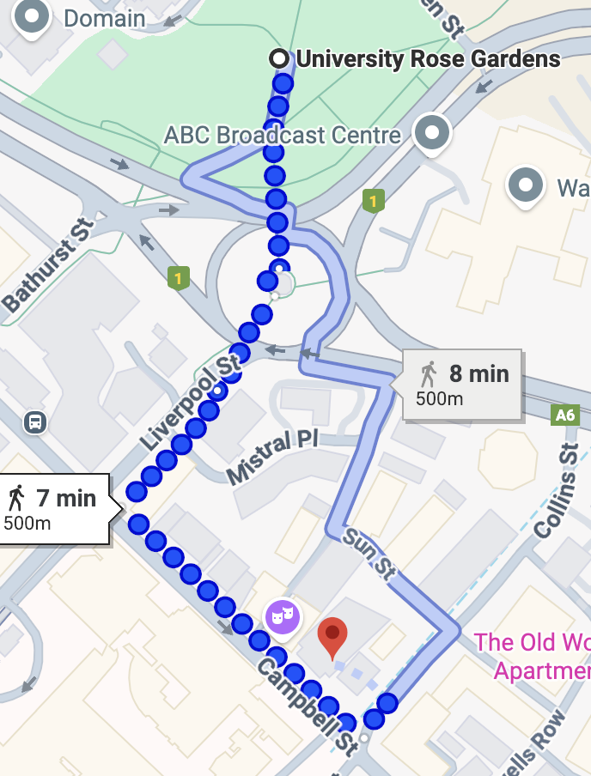

If you need a break from the event at any time, you can go to the Quiet Space. The Quiet Space is located near the main entrance.

If you need captioning, Auslan interpreting or any other access requirement, please let us know when you register for a ticket.

Contact information

If you have any questions about the Forum, including more information about accessibility, you can contact University Cultural Collections staff on galleries@utas.edu.au.

To register join the waitlist for the Forum, visit:

https://www.theatreroyal.com.au/shows/barriers-belonging-forum

If you want more information about the event, visit:

www.arts.tas.gov.au/inclusive-arts/from-barriers-to-belonging

If you want more information about The Hedberg, including venue accessibility and transport options, visit: www.theatreroyal.com.au/accessibility

