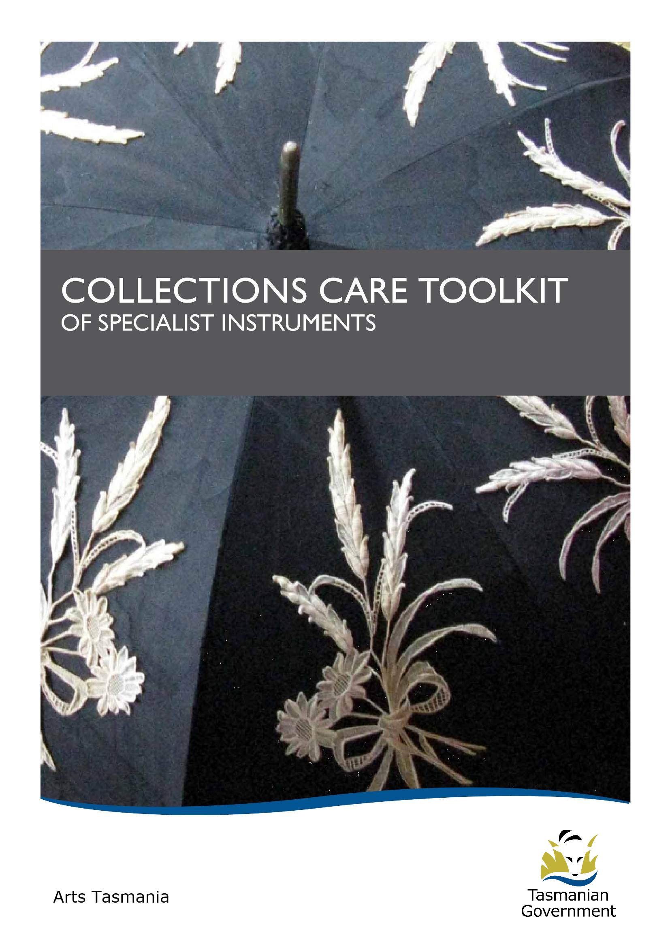
COLLECTIONS CARE TOOLKIT

Arts Tasmania’s Small Museums and Collections Program and Roving Curators are pleased to be able to provide a Collections Care Toolkit of specialist instruments, available for loan to monitor air velocity, light, humidity and temperature levels in your museum environment.

The development of this Toolkit of specialist instruments is a Small Museums and Collections Panel initiative to support small museums in the care of their collections.

The following instruments are available for loan:
- Lutron LM-8000 - 4 in 1 - Environment meter - ANEMONOMETER, HYGROMETER, THERMOMETER and LIGHT METER

- General DTH 800 - DIGITAL TEMPERATURE/HUMIDITY MONITOR WITH CLOCK
Memory function recalls Max/Min reading of temperature and humidity
Automatic daily updates of Max/Min reading of temperature and humidity

- Sper Scientific UVA/B LIGHT METER - 85009
This portable instrument measures damaging UV (ultraviolet) light, in both natural and man-made environments.

- Testo 623 - AMBIENT CONDITION RECORDER
Light and Humidity recorder
Cover image: Parasol, from the Heritage Highway Museum Collection, Campbell Town.
The loan period is for either 1, 2 or 3 months and is confirmed by the completion of the attached Loan Agreement Form.

A Quick Use Guide is provided with each instrument as well as the Instructional Manual. The Roving Curators are available to demonstrate the use of the instrument(s) and can be contacted in regard to any further enquiries.

Roving Curator contact details
Veronica Macno
Email: Veronica.Macno@arts.tas.gov.au
Phone: (03) 6336 3023
Melissa Smith
Email: Melissa.Smith@arts.tas.gov.au
Phone: (03) 6336 3022

RECOMMENDED MUSEUM ENVIRONMENTAL LEVELS
The importance of monitoring and maintaining safe environmental conditions in museums and collection spaces is recommended by the National Standards for Australian Museums and Galleries.

PRINCIPLE C2
The museum preserves its significant collections for future generations

STANDARD C2.2
The museum actively strives to create and maintain an appropriate and stable environment for its collection.

BENCHMARK C2.2.1
Approaches to storage and display, show appropriate understanding of the collection’s condition and the environmental requirements of individual items.
Recommended Relative Humidity Levels
The maximum recommended humidity level in museums is determined by the point at which mould and fungal growth starts. Mould and fungi need at least 65% RH to develop. To provide a safe margin, it is recommended that the RH does not exceed 60%.
The recommended levels in Australian museums are 50% +/- 5% however; some materials like metals prefer a lower relative humidity to prevent corrosion (40-45%).
Recommended Temperature Levels
The recommended temperature for safe-keeping of collections in museums, galleries and libraries ranges from 18°C to 22°C. Non-public storage areas may be kept at a lower temperature.
Recommended Light and UV Levels
The intensity of visible light is measured with a light meter, which gives a reading in
lux (1 lux = 1 lumen per square metre).

Total Light exposure (luxhours) = exposure time (hours) x brightness of illumination (lux)
Sensitive materials
Costumes and other textiles, fur and feathers, dyed leather, prints, drawings, watercolours, stamps, manuscripts, coloured and many types of old photographs, miniatures, transparencies, and unprimed thinly coloured paintings on canvas.
- 50 lux is the maximum (visible light)
- Maximum annual exposure 200 kilolux hours (visible light)
- Preferably below 1 (microwatt per cm²) (UV light)

Moderately sensitive materials
Oil and tempera paintings, lacquerware, plastics, wood, furniture, horn, bone, ivory, undyed leather and minerals

- 250 lux is the maximum (visible light)
- Maximum annual exposure 650 kilolux hours (visible light)
- Preferably below 1 (microwatt per cm²) (UV light)

Non-sensitive materials
Stone, ceramic, glass, and metal

- Do not unnecessarily expose them to very high lighting or UV levels.

SPECIALIST INSTRUMENTS FOR LOAN

LUTRON LM-8000 4-IN-1 ENVIRONMENTAL METER
(Anemometer, Hygrometer, Thermometer and Light Meter)

The Lutron LM-8000 is a hand held device for instant readings that measures airflow, temperature, visible light and relative humidity. It has a lightweight low-friction ball vane providing high accuracy at high and low air velocity. It is not suited to long-term readings.

Quick Use Guide
- Turn on the Power button
- Function button to change options
- It has adjustable units
Temperature: ºC / ºF
Light: Lux, Ft-cd (foot candles)
Air Velocity: mph, km/hr, knots (m/s)
Humidity: Relative (%RH)
- The Hold button maintains the current measured value
- It will only measure ambient air temperature
- Unit/Zero button is for light reading – you will need to cover the white ball and press Unit/Zero to set to zero, then move into light to activate the sensor

GENERAL DTH 800 – DIGITAL TEMPERATURE HUMIDITY MONITOR WITH CLOCK
A simple hand held device for instant readings of temperature and relative humidity. It is also a clock with an alarm. There is an optional daily reset feature. It is not suited to long-term readings.

Quick Use Guide
- There is no On/Off switch – battery needs to be inserted or removed
- The temperature and humidity are measured continuously unless clock being set
- Temperature can be displayed in °F or °C
- The display shows temperature and humidity simultaneously
- By pressing the MAX/MIN key the Maximum and Minimum temperature/ humidity can be viewed – use the RESET key to return to the current temperature/humidity record
- To measure the Maximum/Minimum temperature and humidity records in a current day, switch the slide to Daily (at the back of the instrument)
This will provide a Maximum/Minimum reading for the day (relative to when you turn it on). It will reset to current Maximum/Minimum readings from 0.00 every day
SPER SCIENTIFIC UVA/B LIGHT METER - 850009
The Sper Scientific UVA/B Light Meter is a lightweight, portable instrument that measures damaging UV (ultraviolet) light both natural and manmade environments. The UV Light Meter measures long and medium wave UV-A/B light.

Quick Use Guide
To simply spot measure a current reading of UV:
- Press and HOLD button to turn the meter on and off
- Press MODE continuously to cycle through the modes (ignore Zero, Type, and Time at this stage)
- Select UNIT – press S to choose µW/cm² (microwatts per cm²)
- Press MODE again to cycle to MAX/MIN/AVG mode, which is the Normal Mode
- The primary display will show the current measurement value of UV
- The secondary display (smaller number) is relevant to advanced functions and data recording (and can be ignored at this stage)
- To view the Minimum, Maximum or Average values of the current reading, press S continuously to select subcategory modes of None, Maximum Hold, Minimum Hold and Average Hold
- This device also has a Memory option to manually/auto record UV readings. However, we suggest that the initial spot check of levels will indicate if action needs to be taken to reduce UV levels (eg. Fluorescent light filters/covers, replace existing lights with LEDs)
- If you have a reading over 1 µW/cm² action needs to be taken
TESTO 623 AMBIENT CONDITION RECORDER - HYGROMETER
This instrument measures Maximum and Minimum temperature and relative humidity. An analysis of the current and past ambient conditions is possible. There is an optional daily reset feature. It is able to record short to long term readings displayed as a histogram over a 5 min, 10min, 1hr, 2hr, 12hr, 24hr period.
Quick Use Guide
- There is no On/Off switch – battery needs to be inserted or removed
- The date and time has been preset and the scale on the graph is set to AUTO
- On the right hand side of the screen is displayed the current Temperature (°C) and Humidity (%) values
- To the left of the screen a histogram shows the profiles for humidity /temperature – to alternate press the button
- Each bar on the histogram represents the average temperature/humidity for the selected time interval
- To set the time interval, (displayed at the bottom of the histogram) press the button. An overview of up to 12 days can be viewed
- The flashing arrow (set at the bottom of the far right bar of the histogram) references the current (time measurement) – this corresponds with the time and date shown
- To preview other time increments (bars to the left) on the histogram use either the or buttons to scroll along the axis
Continued on next page…
- At each bar you can then press the Max. or Min. button for that time period – otherwise the Average reading will be shown
- Press ESC to go back to current settings
- The SET button (held for 2 seconds) allows various functions and values to be set or saved.

Many of the functions have been pre-set to increase ease of use

LOAN AGREEMENT FORM - SPECIALIST INSTRUMENTS
Please complete, sign authorisation and return one copy to the Roving Curator/s
1 | Lender
Name: Arts Tasmania
Street address: Level 1, 12-16 St John St
City/Suburb: Launceston |  |  |  |  |  | Postcode: 7250
2 | Borrower
Museum name:
Contact Person: |  |  | Position:
Work Phone: |  |  | Mobile:
Email:
Street address:
City/suburb: |  |  |  |  |  | Postcode:
Postal address:
City/suburb: |  |  |  |  |  | Postcode:
3 | Loan details
Period of loan (tick): 1 month |  |  |  |  | 2 month |  |  | 3 month
Start date:
Finish date:
Items borrowed (tick): Lutron LM -8000 4-in-1 Environment meter
General DTH 800 - Digital temperature/humidity monitor with clock
Sper scientific UVA/B light meter – 85009
Testo 623 - ambient condition recorder
4 | Loan Conditions
The Lender hereby agrees to lend the Borrower the instrument(s) in accordance with the following terms and conditions during the period of the loan agreement.
- Period of loan: The period of loan is for either 1, 2 or 3 months and is confirmed by the completion of the attached Loan Agreement Form.
- Use and repair: The Borrower agrees to keep the borrowed instrument(s) in the same repair and condition as it was when received and shall not permit or suffer to permit any repair or alteration to its condition as received. The Museum will be responsible for the cost of any repair required to the borrowed instrument(s), should the condition of the borrowed instrument(s) change during the period of the loan.
- Loss and damage: The Borrower is responsible for any damages or loss to the borrowed instrument(s) whether in transportation, storage or use and regardless of who may be responsible. Any necessary repair or replacement costs will be required to be paid by the Borrower.
- Assignation: The Borrower agrees not to assign over or in any way dispose of or part with possession of the instrument(s) or any part thereof without consent in writing from the Lender.
- Return of instrument(s): Upon termination of the loan the Borrower will return the instrument(s) to the Lender at the address specified in writing by the Lender prior to the termination of the loan. If no address is specified then the instrument(s) will be returned to the address of the Lender specified in this agreement.
- Insurance: Insurance against damage while in transit to and from the Museum and while in use is the responsibility of the Borrower.
- Authorisation: I have read the terms and conditions and accept them.

5 | Authorisation
Arts Tasmania |  | Borrower
Signature: |  | Signature:
Name: |  | Name:
Position: |  | Position:
Date: |  | Date:

Heritage Collections Council, 1998, re Collections – Caring for Collections across Australia, Chapter 3.

